|  |  |  |  |
| --- | --- | --- | --- |
|  | **VERY HIGH RESOLUTION REMOTE SENSING OF *PORTULACARIA AFRA* CANOPY COVER** | |  |
|  | By Dugal Harris | |  |
|  | *Thesis presented in partial fulfilment of the requirements for the degree of Master of Science at the Stellenbosch University.* | |  |
|  |  | |  |
|  | Supervisor:Prof A van Niekerk  December 2014 |  | |
|  |  | |  |

DECLARATION

By submitting this report electronically, I declare that the entirety of the work contained therein is my own, original work, that I am the sole author thereof (save to the extent explicitly otherwise stated), that reproduction and publication thereof by Stellenbosch University will not infringe any third party rights and that I have not previously in its entirety or in part submitted it for obtaining any qualification.

|  |  |
| --- | --- |
| Date: |  |

Copyright © 2013 Stellenbosch University

All rights reserved

SUMMARY

Summary

**KEY WORDS**

Keywords

OPSOMMING

Opsomming

**TREFWOORDE**

ACKNOWLEDGEMENTS

I sincerely thank:

* My supervisor Prof Adriaan van Niekerk for his valuable guidance and support.
* Jan Vlok for initially suggesting the topic, providing expert botanical knowledge of my study area and for his generous assistance with ground truthing in the field.
* The Gamtoos Irrigation Board and Andrew Knipe for funding the research.
* Julie Verhulp, Raoul Duesemi and the rest of the staff at National Geospatial Information for their help with sourcing imagery of the study area.
* Adrian Roos of Intergraph SA for providing an evaluation license for the Intergraph ZIPPS calibration software.
* Bernhard Jacobs of Geospace for useful discussions on image calibration and for providing the camera calibration data.
* Theo Pauw and Garth Stephenson of the Centre for Geographical Analysis for providing software support and server access.

CONTENTS

DECLARATION ii

SUMMARY iii

OPSOMMING iv

ACKNOWLEDGEMENTS v

CONTENTS vi

TABLES viii

FIGURES ix

APPENDICES x

ACRONYMS AND ABBREVIATIONS xi

CHAPTER 1: INTRODUCTION 1

1.1 SIGNIFICANCE AND RATIONALE 4

1.2 PROBLEM STATEMENT 7

1.3 RESEARCH AIM AND OBJECTIVES 7

1.4 STUDY AREA 7

1.5 METHODOLOGY 8

CHAPTER 2: CROSS CALIBRATION OF VHR IMAGE MOSAICS 11

2.1 ABSTRACT 11

2.2 INTRODUCTION 11

2.3 METHODS 15

2.3.1 RADIOMETRIC FORMULATION 15

2.3.2 STUDY SITE, DATA COLLECTION AND PREPARATION 19

2.3.3 ACCURACY ASSESSMENT 20

2.4 RESULTS 22

2.4.1 Mosaicing 22

2.4.2 SPOT 5 comparison 25

2.5 CONCLUSIONS 28

CHAPTER 3: FEATURE CLUSTERING AND RANKING 30

3.1 ABSTRACT 30

3.2 INTRODUCTION 30

3.3 DATA AND GROUND TRUTH 33

3.4 FEATURES 34

3.5 METHOD 36

3.6 RESULTS AND DISCUSSION 37

3.6.1 Standard Feature Selection 37

3.6.2 Clustering and Ranking 38

3.7 CONCLUSIONS 41

CHAPTER 4: VERY HIGH RESOLUTION MAPPING OF *PORTULACARIA AFRA* CANOPY COVER 44

4.1 ABSTRACT 44

4.2 INTRODUCTION 44

4.3 STUDY AREA 46

4.4 DATA AND GROUND TRUTHING 47

4.5 METHODOLOGY 51

4.6 FEATURES 52

4.7 FEATURE SELECTION 55

4.8 CLASSIFICATION 56

4.9 RESULTS AND DISCUSSION 59

4.9.1 Feature Selection 59

4.9.2 Classification 62

4.10 CONCLUSIONS 69

REFERENCES 72

**PERSONAL_COMMUNICATIONS 6**

**APPENDICES 7**

TABLES

Table 2.2 Sensor spectral bandwidths 21

Table 2.1 Mean absolute difference between calibrated SPOT 5and DMC images 28

Table 3.1 Class descriptions 33

Table 3.2 Ground truth size 34

Table 3.3 Features 34

Table 3.4 Experiment 1: Forward selection results for different data sets 37

Table 3.5 Experiment 2: Forward selection results for different selection criteria 38

Table 3.6 Experiment 3: Feature selection results for different search methods 38

Table 3.7 Ranked clusters 40

Table 3.8 Experiment 4: Feature clustering and ranking results for different data sets 40

Table 3.9 Experiment 5: Feature clustering and ranking results for different selection criteria 41

Table 3.10 Classifier performance comparison 41

Table 4.1 Field ground truth site information 49

Table 4.2 Class descriptions 49

Table 4.3 Image ground truth size 51

Table 4.4 Features 55

Table 4.5 Ranked clusters 62

Table 4.6 Classifier parameters 64

Table 4.7 Classifier performance comparison 64

Table 4.8 Decision tree three class confusion matrix 65

Table 4.9 Decision tree two class confusion matrix 66

Table 4.10 Decision Tree field canopy cover estimates 66

FIGURES

Figure 1.1 Intact and degraded subtropical thicket 1

Figure 1.2 CIR Image of *P. afra* Thicket 6

Figure 1.3 Location of the study are within the Little Karoo 8

Figure 1.4 Research design 10

Figure 2.4 SPOT scene and mosaic extents 21

Figure 2.1 Camera calibrated mosaic on MODIS reference image background 23

Figure 2.3 Radiometrically calibrated mosaic on MODIS reference image background 24

Figure 2.2 Radiometric correction of hot spot image. (a) Uncalibrated image showing hot spot. (b) RGB **M** raster. (c) Calibrated image. 25

Figure 2.5 difference image. 27

Figure 3.1 Clustering of correlated features 39

Figure 4.1 Little Karoo study area 47

Figure 4.2 Study area *P. afra* habitats and field ground truth sites 48

Figure 4.3 Matjiesvlei2 ground truth site 49

Figure 4.4 Hand labelled ground truth 51

Figure 4.5 Clustering of correlated features 60

Figure 4.6 Groenfontein classification (Habitat: valley thicket with Spekboom) 67

Figure 4.7 Matjiesvlei classification (Habitat: arid thicket with Spekboom) 68

Figure 4.8 Rooiberg classification (Habitat: arid thicket with Spekboom and Fynbos mosaic) 68

Figure 4.9 Grootkop classification (Habitat: arid thicket with Spekboom and Succulent Karoo mosaic) 69

APPENDICES

|  |  |  |
| --- | --- | --- |
| Appendix A: | Description |  |
| Appendix B: | Description |  |

ACRONYMS AND ABBREVIATIONS

|  |  |
| --- | --- |
| BE | Backward elimination |
| BRDF | Bi-directional reflectance distribution function |
| DGPS | Differential GPS |
| FS | Forward selection |
| GIS | Geographical information system |
| GLCM | Grey level co-occurrence matrix |
| GPS | Global positioning system |
| KNN | K-nearest-neighbour |
| LBP | Local binary pattern |
| LUT | Look up table |
| NDVI | Normalized difference vegetation index |
| NGI | Chief Directorate: National Geo-spatial Information |
| NIR | Near-infrared |
| PCA | Principal components analysis |
| PSF | Point spread function |
| RBF | Radial basis function |
| RM | Ray matching |
| RRN | Relative radiometric normalisation |
| RTM | Radiometric transfer model |
| RVI | Ratio vegetation index |
| SBFS | Sequential backward floating search |
| SFFS | Sequential forward floating search |
| SNR | Signal to noise ratio |
| SVM | Support vector machine |
| TOA | Top of atmosphere |
| VC | Vapnik-Chervonenkis |
| VHR | Very high resolution |
|  |  |
|  |  |
|  |  |
|  |  |

# INTRODUCTION

*Portulacaria afra* (Spekboom) is an evergreen succulent tree growing to 2.5m, with small fleshy leaves. It occurs in the Subtropical Thicket biome and is the dominant species in the arid and valley thicket habitat types (Vlok, Cowling & Wolf 2005). “The Subtropical Thicket habitat types are most easily recognized by the occurrence of woody trees, spinescent shrubs and a relative abundance of succulents. When occurring as solid stands the vegetation can form impenetrable dense thickets, but this is uncommon in the Little Karoo. In most of the area the Subtropical Thicket vegetation occurs as discrete bush-clumps, usually in a matrix of Succulent Karoo vegetation” (Vlok, Cowling & Wolf 2005: 41). While *P. afra* is tolerant of browsing by indigenous herbivores, it is highly susceptible to over browsing by goats (Marais, Cowling & Powell 2009; Sigwela et al. 2009; Mills et al. 2007; Mills et al. 2005). Poorly managed goat grazing transforms thicket into sparsely scattered thicket clumps, isolated trees and a covering of herbs (Mills et al. 2005). Figure 1.1 shows an example of degraded and intact *P. afra* thicket across a fence-line in the south-eastern Cape. Once thicket has been severely degraded, removing grazing pressure does not result in natural recovery (Mills et al. 2007; Vlok, Cowling & Wolf 2005).

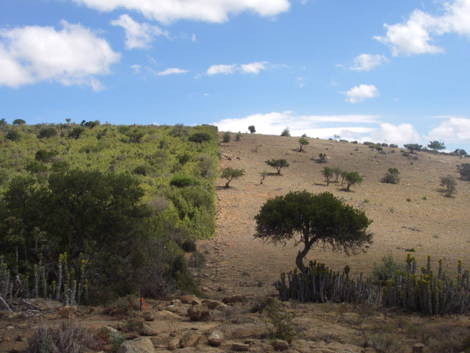

Figure 1.1 Intact and degraded subtropical thicket

Source: (Restoration Research Group 2012)

There is considerable interest in actively restoring degraded thicket habitat for several reasons. *P. afra* is unusually effective at storing carbon compared to other arid region vegetation. Measurements at a number of sites indicate that average rates of carbon storage lie between 1.2 and 4.2 t C ha-1 yr-1 (Van der Vyver et al. 2013; Mills & Cowling 2006). Further measurements in Van der Vyver et al. (2013) support these figures. Comparison of degraded and intact sites has shown that restoration could sequester the order of 100 t C ha-1 (Van der Vyver et al. 2013; Mills et al. 2005; Marais, Cowling & Powell 2009). These numbers compete with the carbon storage capacity of mesic forests (Mills et al. 2005). Carbon captured through restoration of *P. afra* can be traded as credits on the international carbon market. Using this as a source of funding for landscape-scale restoration is economically viable (Mills et al. 2007; Marais, Cowling & Powell 2009). *P. afra* has the uncommon ability to switch between C3 and CAM photosynthetic systems depending on season (Guralnick & Ting 1986). This means it is productive year-round which likely contributes to its substantial sequestration abilities (Mills & Cowling 2010). *P. afra* propagates vegetatively and can thus be grown from cuttings (Stuart-Hill 1992) which means that costs of restoration can be reduced by avoiding nursery expenses (Mills & Cowling 2010).

Subtropical Thicket provides an important source of food for many herbivores, including domesticated livestock (Thompson et al. 2009; Vlok, Cowling & Wolf 2005). Re-establishment of *P. afra* in degraded areas will help prevent soil erosion, reduce flood severity and improve water quality (Van Luijk et al. 2013; Mills & Cowling 2006). It is also attractive from an employment perspective; potentially creating thousands of jobs in impoverished areas, if implemented on a large scale. Increased biodiversity could help improve income from tourism and provide sustained access to wood, fruit and medicines for local communities (Mills et al. 2007).

The dense canopy of *P. afra* facilitates an accumulation of soil organic matter which in turn significantly improves the water-holding capacity and fertility of the soil (Adie & Yeaton 2013; Mills & Cowling 2010; Lechmere-Oertel et al. 2008; Mills & Fey 2004). *P. afra* acts as a nurse plant. The provision of shade, improved soil quality and moisture retention, creates a favourable environment for other plants to germinate (Adie & Yeaton 2013; Mills & Cowling 2010). It has been observed that over a period of 40 to 50 years, woody canopy and other species re-establish in *P. afra* restoration areas to a degree that restored thicket is compositionally comparable to intact thicket (Van der Vyver et al. 2013). An investigation into the feasibility of accelerating the restoration of woody canopy species through planting in *P. afra* restoration sites was conducted, but it was found that survival rates were poor and restoration costs prohibitive (Vyver et al. 2012). It seems the most practical option for ecosystem restoration is to plant *P. afra* and allow other species to re-establish naturally through spontaneous recruitment (Mills et al. 2007).

Restoration research is being conducted as part of the Subtropical Thicket Restoration Project (STRP), which is an initiative of the Working for Woodlands Programme. “To evaluate methods of spekboom restoration, a partnership has been forged among scientists, government and an implementing agency. The South African government’s Working for Woodlands Programme … has engaged a group of scientists to assist in evaluating effective ways of using spekboom cuttings for restoration under different conditions …. The programme is being managed by an implementing agency, the Gamtoos Irrigation Board (GIB), rated as one of the best agencies used by Working for Water.” (Mills et al 2010: 9) *P. afra* restoration is also actively being conducted and monitored in the Baviaanskloof Nature Reserve, Addo Elephant National Park and the Fish River Reserve in the Eastern Cape (Mills et al. 2010). Approximately 1630 ha had been restored in these areas in 2012 (Vyver et al. 2012).

Supporting spatial information is needed to aid the *P. afra* restoration process. Candidate restoration areas need to be identified. There are many factors to consider when selecting appropriate sites (Curran et al. 2012; Knight et al. 2011). A map of *P. afra* canopy cover is a key input to this decision-making process. Canopy cover can be used to estimate the expected carbon storage resulting from restoration. This provides an indication of the economic feasibility of restoration. Measures of intact canopy cover in a similar habitat to the restoration area are used to determine an appropriate planting density. Restoration progress can be monitored by updating the canopy cover map over time which would also assist in the carbon accounting required for trading credits on the international market (Mills et al. 2010). The canopy cover map would also be a useful tool for deepening the present understanding of the Subtropical Thicket biome.

A detailed vegetation map of the Little Karoo has been created at a 1:50000 scale (Vlok, Cowling & Wolf 2005). Using this map, a degradation mapping study was conducted in the Little Karoo (Thompson et al. 2009). It was successful at using MODIS data to estimate intact, moderate and severe degradation levels of *P. afra* thicket at a 250m pixel resolution. Currently, there is an initiative to involve private land-owners in the restoration project in order to broaden its impact (Curran et al. 2012; Mills et al. 2010). Restoration planning at farm-level will require map scales of 1:10000 or better to provide sufficient spatial detail for working with expected stand sizes of the order of 50 hectares. To achieve sufficient accuracy for carbon storage estimations, it will be necessary to estimate canopy cover in finer detail than the three levels of degradation used in Thompson et al. (2009) and at a finer spatial resolution. There is thus a need to further the work of Thompson et al. (2009) to produce maps of both a higher spatial and canopy cover level resolution.

## SIGNIFICANCE AND RATIONALE

Measures of canopy cover can be used to infer biomass for individual species (Ludwig, Reynolds & Whitson 1975). In the context of climate change, biomass is an important variable for monitoring ecosystem carbon dynamics. Carbon absorbed by vegetation and soils will play a significant role in efforts to reduce atmospheric CO2 and in determining the development of future climate change (Eisfelder, Kuenzer & Dech 2012; Lu 2006). Canopy cover or biomass is also important from a perspective of understanding environmental processes and ecosystem services. Improved biomass is related to increased biodiversity (Lu 2006; Fabricius, Burger, and Hockey 2003), reduced erosion and improved soil fertility and water-holding ability (Eisfelder, Kuenzer & Dech 2012; Mills & Cowling 2010; Lechmere-Oertel et al. 2008; Mills & Fey 2004).

Under the Kyoto Protocol, ratified countries are legally bound to reduce CO2 emissions to capped levels. If these levels are exceeded, countries can make up the deficit by buying carbon credits from another country that was able to reduce its emissions below its target level (Mills et al. 2010). The Clean Development Mechanism (CDM) is a means by which developing countries can run sequestration projects and trade carbon credits on the international market. There are also the Voluntary Carbon Standard (VCS), Community and Climate and Biodiversity Standard (CCBS) which work on a similar basis to the CDM, but don’t require authorisation by the host country. Under these schemes there are legal provisions that require rigorous accounting of stored carbon. These measurements are time consuming and costly when performed manually (Eisfelder, Kuenzer & Dech 2012; Lu 2006). Canopy cover measurements are currently being done by visual inspection in the field. There is a need for greater accuracy and repeatability than is possible with this technique. A *P. afra* canopy cover map would serve as a first step towards achieving the required carbon storage measurements via remote sensing on a large scale.

The benefits of *P. afra* restoration are manifold and include benefits for local communities. The STRP has placed a strong emphasis on stakeholder engagement and community development (Marais, Cowling & Powell 2009). Restored areas will provide increased capacity for supporting judiciously managed livestock and employment for thousands of workers if restoration is implemented on a large scale (Mills et al. 2010). Employment is particularly relevant for the Eastern Cape where unemployment rates are amongst the highest in South Africa at roughly 27% (Statistics South Africa 2011).

This research presents a number of challenges from a technical remote sensing perspective. There is VHR (0.5m/pixel) multi-spectral data with national coverage available from Chief Directorate: National Geo-spatial information (NGI) (National Geo-spatial Information 2012). This imagery represents a rich source of information, but to date it has only been used for topographical mapping and photo-interpretation. To the best of the author’s knowledge, this is the first study to exploit this imagery for automated vegetation monitoring. Use of VHR imagery for estimation of environmental variables is fairly uncommon, especially over large areas such as the Little Karoo (Eisfelder, Kuenzer & Dech 2012; Lu 2006). Figure 1.2 shows an example colour infra-red (CIR) image of *P. afra* thicket from NGI.

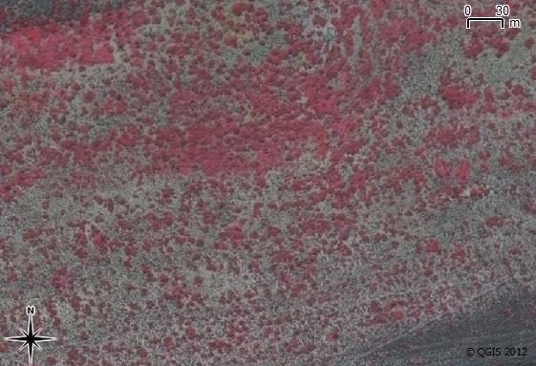

Figure 1.2 CIR Image of *P. afra* Thicket

Another aspect of this research that has been relatively unexplored in the literature is measuring some aspect of degradation, such as a reduction in canopy cover, in an arid environment. Research on measurement of indicators in forest ecosystems is fairly well established (Lu 2006; Wulder et al. 2004; Lévesque & King 2003). Arid regions present some remote sensing challenges not typically encountered in forests. These include the naturally sparse vegetation cover and mixing of soil and vegetation spectra (Eisfelder, Kuenzer & Dech 2012; Thompson et al. 2009). Arid regions cover roughly one third of the terrestrial land surface (Food and Agriculture Organization (FAO) 1989) and are particularly sensitive to degradation (Mills et al. 2005; Stuart-Hill 1992). Remote sensing techniques applicable to arid environments are therefore of importance.

Dealing with sources of unwanted variation is a recurring difficulty reported in the remote sensing literature (Eisfelder, Kuenzer & Dech 2012; Baraldi et al. 2010; Lu 2006). Achieving an accurate canopy cover mapping over a large spatial scale and using a mosaic of images acquired at different times requires an algorithm that is robust to many of the variations commonly encountered. These include topography, *P. afra* habitat and shadow variations. Dealing with these challenges has comprised a significant portion of the research effort.

## PROBLEM STATEMENT

Habitats supporting *P. afra* have been degraded by overgrazing over much of their range. There is significant interest and a growing body of research in *P. afra* restoration. Restoration projects will generate employment, restore ecosystem services and produce carbon credits that can be traded to offset restoration costs. There is a need for spatial information, in the form of *P. afra* canopy cover maps, to support restoration projects in the identification of suitable areas to plant and in the monitoring of restoration progress at repeated intervals. Restoration is planned for large areas of the Little Karoo and Eastern Cape. Map scales of at least 1:10000 are required to provide sufficient accuracy for farm-level restoration planning. The production of detailed, large scale *P. afra* canopy cover maps using manual (i.e. image interpretation) methods is prohibitively time-consuming and expensive, particularly for large areas such as the Little Karoo. An automated or semi-automated image analysis technique that is robust enough to deal with the inherent temporal, topographical and radiometric variations in VHR aerial imagery is needed to monitor *P. afra* canopy cover dynamics in the Little Karoo.

## RESEARCH AIM AND OBJECTIVES

The research aim is to develop an automated or semi-automated image analysis technique to accurately estimate *P. afra* canopy cover in pristine and transformed areas using very high resolution (VHR) aerial imagery, covering large areas.

To achieve the research aim, the following objectives have been set:

1. Review the literature on *P. afra* restoration, vegetation and canopy cover mapping in arid environments, as well as vegetation and canopy cover mapping using VHR imagery.
2. Carry out a field study to establish suitable reference sites and determine the actual (ground truth) canopy cover for each site.
3. Source, rectify and radiometrically calibrate aerial imagery from NGI.
4. Develop a classifier that accurately distinguishes *P. afra* from surrounding vegetation.
5. Apply the classifier to imagery of the study area and interpret and evaluate the results.

## STUDY AREA

The Little Karoo as defined in Vlok, Cowling & Wolf (2005), was selected as the area of interest. It is a semi-arid region of great biodiversity lying between two mountain ranges. Three biomes considered to be biodiversity hotspots of global significance intersect in the Little Karoo (Thompson et al. 2009). A total of 54 habitat types were identified by Vlok, Cowling & Wolf (2005) in their vegetation map, of which ten support *P. afra*. Subtropical Thicket can occur in a continuous extent or as solid clumps against a background of another vegetation type, termed the “mosaic”. The Subtropical Thicket biome makes up 35.3% of the Little Karoo which has a total area of 2 343 900 ha (Vlok, Cowling & Wolf 2005). It was found that 89.3% of the *P. afra* thicket was degraded to some extent in a study area comprising roughly half the area of the Little Karoo (Thompson et al. 2009). The Little Karoo was chosen as a study area because it contains a significant portion of *P. afra* suited and degraded habitat and has been targeted for restoration. It is also beneficial that a number of relevant studies have been performed in the area (Thompson et al. 2009; Forsyth, Vlok & Reyers 2008; Vlok, Cowling & Wolf 2005).

To expedite computing times and reduce storage space required for the VHR imagery, a smaller portion of the Little Karoo was chosen as the study area (Figure 1.3). This area was chosen to be as representative of the variation in the Little Karoo as possible. It consists of four different aerial survey jobs flown at different times and thus still poses a challenge from a remote sensing perspective. It also includes examples of all the different biomes and nine of the ten habitat types supporting *P. afra* as defined by Vlok, Cowling & Wolf (2005).

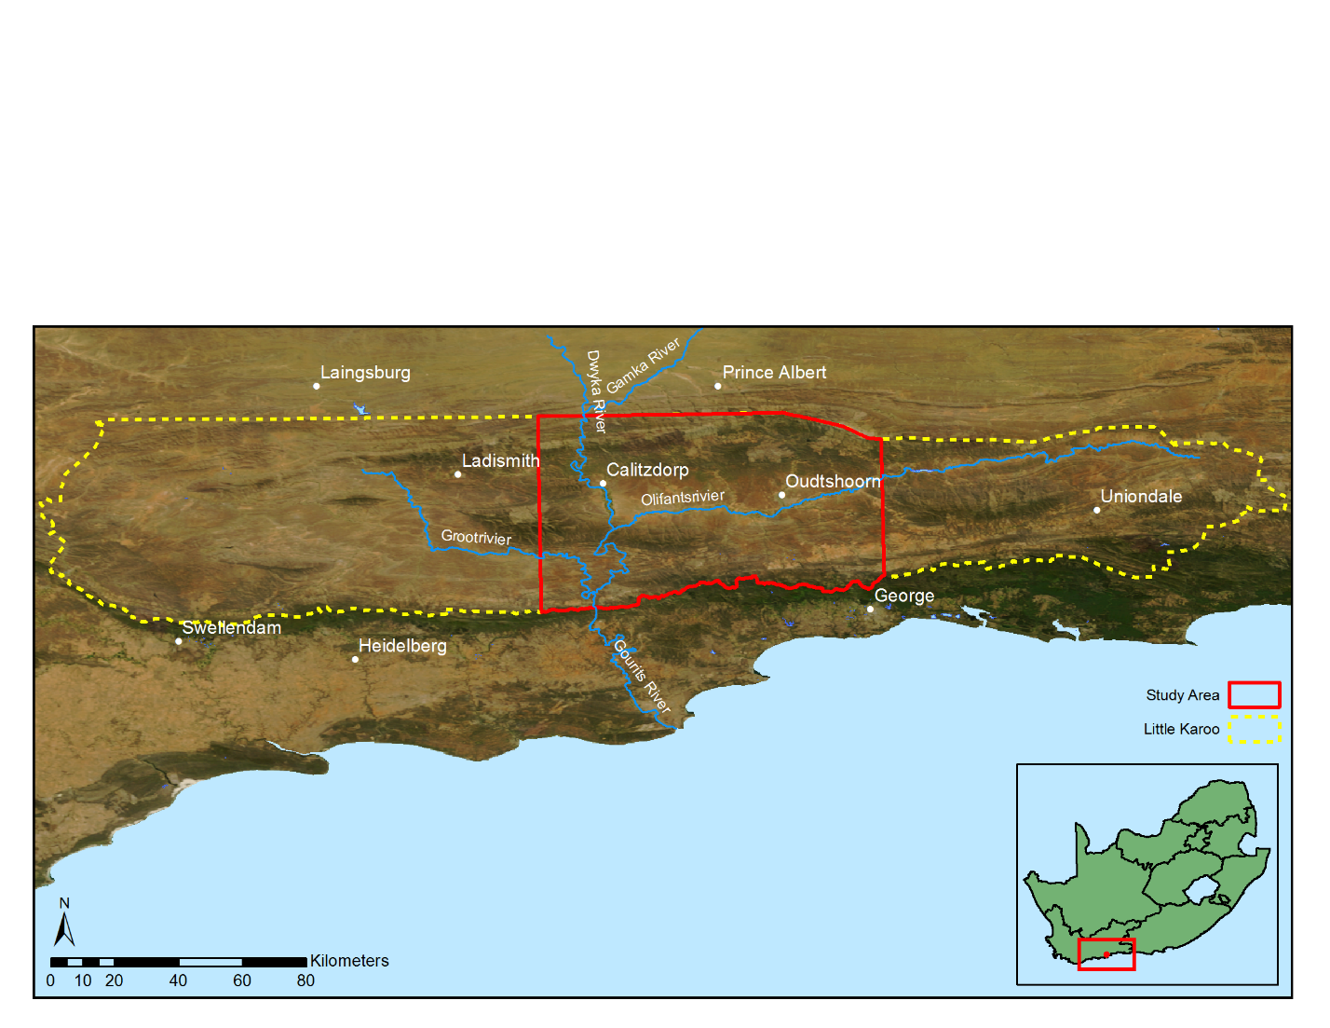

Figure 1.3 Location of the study are within the Little Karoo

## METHODOLOGY

Canopy cover estimations are currently being conducted manually using visual inspection in the field. While this is a common approach for measuring environmental indicators, it is time consuming and only practical for small areas (Eisfelder, Kuenzer & Dech 2012; Lu 2006). A visual inspection is also prone to repeatability issues due to the subjectivity of the inspector. *P. afra* restoration is envisioned for large areas of the Eastern Cape and Little Karoo and will require monitoring of plant growth over time. Repeatability and accuracy constraints on carbon measurements are stringent in order to achieve the necessary accreditation for carbon trading in schemes like the CDM. This research investigates the use of quantitative remote sensing methods for estimating *P. afra* canopy cover. Remote sensing methods are common for biomass estimation (Eisfelder, Kuenzer & Dech 2012; Lu 2006) and is chosen as it will facilitate accurate canopy cover estimation of large areas and at repeated intervals. Using the categorisation of Mouton (2001), this research can be regarded as a methodological study that is experimental in nature. The research design is shown in Figure 1.4 and detailed in the following chapters.

An empirical approach was used for developing the canopy cover estimation. Various secondary measurements or features were extracted from the remotely sensed data and used to build a model of *P. afra* canopy cover. Similar approaches for measuring degradation or biomass in an arid environment were successful in Thompson et al. (2009) and Ludwig, Reynolds & Whitson (1975). The accuracy of the model was tested against unseen data as a check against overfitting (Jain, Duin & Mao 2000).

This work is intended to be applied research. Emphasis was placed on producing a map that is both useful and usable (Pierce et al. 2005). This required interaction and communication with stake-holders (Knight et al. 2011), specifically environmental practitioners currently involved in performing canopy cover assessments, the STRP and the GIB, who are the restoration implementing agents (Mills et al. 2010).

There is a tendency for environmental remote sensing to be conducted in an isolated way that does not allocate adequate importance to understanding complex human and ecological processes affecting the data being analysed (Hein et al. 2011; Turner 2003). This naïve approach can lead to models that do not generalise well over varying spatial and temporal conditions. Recognition of the value of multi-disciplinary teams incorporating expert knowledge of local conditions and field experience is given in Knight et al. (2011) and Thompson et al. (2009). This research was undertaken in collaboration with a botanist, Jan Vlok, who has a wealth of experience in the Little Karoo (Thompson et al. 2009; Forsyth, Vlok & Reyers 2008; Vlok, Cowling & Wolf 2005) and with *P. afra* in particular. His insight into local habitat variations and involvement in restoration work was invaluable to the study.

The technical details of radiometric calibration, feature selection and classification are contained in Chapters 2, 3 and 4 respectively. These chapters were written as papers to be submitted to appropriate scientific journals. Short literature reviews and further details on the methodology relevant to each topic are provided in their respective chapters. It was necessary to repeat some material in these chapters to make them coherent in isolation.

Literature review

Imagery acquisition/ preparation

Radiometric calibration

Calibration validation

Classifier design

Interpretation and evaluation

Evaluate imagery suitability

Figure 1.4 Research design

# CROSS CALIBRATION OF VHR IMAGE MOSAICS

## ABSTRACT

While VHR aerial imagery holds great potential for quantitative remote sensing, its use has been limited by unwanted radiometric variation over temporal and spatial extents. Radiometric calibration involves the reduction of these variations so that the imagery is better suited to automated processing, mosaicking and feature extraction. In this paper we propose a simple, yet effective, cross calibration technique for transforming the digital numbers of aerial images to surface reflectance values. A collocated and concurrent well calibrated satellite image is used as a surface reflectance reference to which the individual images are calibrated. The reference satellite sensor needs to be spectrally similar to the aerial sensor. A spatially varying linear model is used to approximate the relationship between the surface reflectance of the reference image and digital numbers of the aerial images. The model parameters are estimated using least squares fitting model that is dynamically generated within a moving window. The technique was applied to a set of 2228 overlapping aerial images captured with an Intergraph DMC camera. A near-concurrent MODIS MCD43A4 image was used as the reflectance reference dataset. The resulting calibrated DMC images were mosaicked and compared to the MODIS reference image. The results show that the calibrated DMC images … The resulting DMC mosaic was also compared to near-concurrent SPOT 5 reflectance image of the same area and it was found that the mean absolute reflectance difference between the SPOT 5 and calibrated DMC mosaic is found to be 3.92%, which compares favourably to other mosaic correction methods. The ability of the technique to implicitly correct for mosaic smoothness, atmospheric influences and bidirectional reflectance distribution function (BRDF) effects, as well as the relative computational effectiveness of the method, makes it an attractive alternative to existing methods.

## INTRODUCTION

VHR imagery is increasingly being used in remote sensing studies (Heumann 2011; Baraldi et al. 2010; Puissant, Hirsch & Weber 2005). The high spatial resolution of these images enables analyses on a finer spatial scale than most satellite based platforms can provide and consequently opens up the exploitation of information such as texture, object-based features and unmixed pixel spectra that is not available or less effective in lower resolution images (Markelin et al. 2012; Collings et al. 2011; López et al. 2011; Chandelier & Martinoty 2009; Honkavaara et al. 2009). Accurate geometric calibration techniques for producing orthorectified images are well established and form part of typical aerial imagery processing workflows (Chandelier & Martinoty 2009). Proper radiometric calibration of aerial imagery is, however, still a challenge. Spatial and temporal radiometric variations in aerial photography limit the extent over which automated or semi-automated remote sensing techniques can be successfully applied (Markelin et al. 2012). Atmospheric influences, viewing geometry, bidirectional reflectance distribution function (BRDF) effects, sensor variations and terrain effects all contribute to radiometric variations in the imagery. The objective of radiometric calibration is to reduce these unwanted variations and to obtain a measurement correlated with some physical surface variable, such as surface reflectance.

There is some confusion and ambiguity around the use of reflectance terminology in the literature (Schaepman-Strub et al. 2006). In this paper “surface reflectance” is used to mean the bi-directional surface reflectance at local solar noon and viewed at nadir. It is worth noting that as it is not possible or practical to correct for all the sources of radiometric variation in aerial imagery and that surface reflectance in most so-called “corrected” or “calibrated” images is only an approximation to the actual value.

Aerial image mosaics are commonly produced for the purpose of visual interpretation. Techniques such as dodging and look up tables (LUTs) are often used to produce a smooth and visually appealing mosaic (López et al. 2011). This kind of adjustment can damage the spectral information content and is not suited to quantitative remote sensing. The popular technique of kernel-based BRDF correction models different scattering modes of the land cover as parameterised kernels and the BRDF as a linear combination of these kernels (Roujean, Leroy & Deschamps 1992). Approaches based on radiometric transfer modelling (RTM), such as ATCOR (Richter & Schläpfer 2002), MODTRAN (Berk et al. 1999) and 6S (Vermote et al. 1997), are used for atmospheric correction. While these methods are successful on single satellite images (refs), mosaics consisting of multiple aerial images present new challenges. The large view angles of aerial imaging cameras cause the solar and viewing geometries to vary significantly throughout the image (Lelong et al. 2008). Aerial campaigns are usually carried out over multiple days resulting in significant variation in BRDF and atmospheric conditions(Collings et al. 2011; Chandelier & Martinoty 2009; Honkavaara et al. 2009). Each land cover also has its own unique BRDF (Honkavaara et al. 2009; Strahler et al. 1999) and corrections should ideally model each of these covers separately(Collings et al. 2010; Honkavaara et al. 2009). Techniques that account for land cover specific BRDF’s require an upfront cover classification which is time-consuming and introduces another potential source of error (ref), especially considering the classification would need to be done on the uncorrected data (ref). While this issue also applies to satellite imagery (ref), the task of identifying different land covers is less onerous at the typically lower spatial resolutions of satellite sensors (ref). Aerial campaigns can also consist of thousands of images making it impractical to apply time consuming atmospheric correction models to every image (López et al. 2011). Even if it was, the approximate nature of BRDF and atmospheric corrections will be much more noticeable in a mosaic of corrected aerial photographs as remnant radiometric variations will result in visible discontinuities between adjacent images (ref if possible).

Approaches to calibrating mosaics of aerial imagery are receiving increasing attention (López et al. 2011; Collings et al. 2011; Gehrke 2010; Chandelier & Martinoty 2009). All of these approaches exploit the fact that adjacent images contain significant portions of overlap and that in a perfectly calibrated mosaic, these overlapping portions of different images should be identical. Collings et al. (2011) introduced a spatially varying linear model to perform combined atmospheric and BRDF correction. The parameters of the model are solved by minimising a cost function that includes costs for internal accuracy of each image, similarity of overlapping image regions and smoothness of the mosaic. In a second stage the entire mosaic is calibrated to absolute reflectance using specially placed ground targets with known reflectance. In Chandelier & Martinoty (2009) a simple three parameter model of the combined atmospheric and BRDF effects is fitted by minimising the difference between “radiometric tie-points”, which are a selection of points in the overlapping image regions. It is a relative calibration method and no adjustment to absolute reflectance is made. A similar approach is used in López et al. (2011). Gehrke (2010) uses standard atmospheric and BRDF methods followed by a relative radiometric normalisation (RRN) step using invariant points in overlapping regions to smooth the mosaic.

A disadvantage of the aerial mosaic calibration techniques described above is their complexity and need for known ground references to achieve transformation to absolute surface reflectance. Calibration to an absolute physical quantity such as reflectance is beneficial as this is an invariant property of the surface (refs)which allows the data to be used in physical models and fused or otherwise used in combination with other calibrated data sources (Downey et al. 2010; Pohl & Van Genderen 1998) and used in multi-temporal studies (Vicente-Serrano, Pérez-Cabello & Lasanta 2008) (refs). The options of placing targets of known reflectance to be captured as part of the mosaic or measuring the reflectance of suitably invariant sites on the ground are often not practical. Many applications make use of archived imagery that had been captured years prior to the commencement of the research and for which concurrent ground measurements are consequently not possible. Measuring the spectral characteristics of specific ground sites is recognised as being labour-intensive and costly (Gao et al. 2013; Chander, Meyer & Helder 2004; Liu et al. 2004). The cross calibration of aerial photographs to well calibrated satellite data provides an alternative to infer the ground measurement and can be used at regular intervals. In cross calibration the reference satellite image should preferably be concurrent and spectrally similar to the uncalibrated images to minimise differences in atmospheric effects, variation of surface reflectance and sensor effects. If viewing and solar geometries differ substantially between the reference satellite and uncalibrated sensor, knowledge of the BRDF of the land cover is necessary to convert for solar and viewing geometry.

The two main approaches to cross calibration are ray matching (RM) and radiative transfer modelling (RTM). In RM a linear model is fitted between the reference and uncalibrated sensors using the top of atmosphere (TOA) radiances of the two sensors (Duelling, Minnis & Nguyen 2004). Identical viewing geometry, atmospheric conditions and spectral responses of the reference and uncalibrated sensors are assumed. In most practical situations, these assumptions are crude approximations. Nevertheless, useful accuracies have been obtained using this approach (Li, Yang & Wang 2012; Jiang & Li 2009; Song 2004).

RTM takes viewing geometry, atmospheric differences and sensor spectral responses into account by using a model such as 6S or MODTRAN to compensate for atmospheric effects and estimate a surface reflectance. A BRDF is often used to convert the surface reflectance to the uncalibrated sensor’s viewing geometry. The RTM model is then used in reverse to simulate the TOA reflectance for the uncalibrated sensor, taking the sensor’s spectral response into account. A linear calibration model is then fitted between the actual uncalibrated and simulated calibrated sensor’s measurements. Many investigations that use this approach have been successful (Gao et al. 2013; Kamei et al. 2012; Li, Yang & Wang 2012; Jiang & Li 2009; Liu et al. 2004; Teillet et al. 2001). However, the images used for these studies are often of a specially selected ground site. Desert regions with flat terrain, clean and dry atmosphere and where the surface reflectance varies little over space and time are favoured (Liu et al. 2004). Some cross calibration studies using the RTM approach have been able to provide radiometric accuracies similar to or better than vicarious techniques (Liu et al. 2004). Differing sensor spectral responses can have a significant effect on sensor measurements depending on the interaction of surface reflectance and sensor (Teillet et al. 2001). While the RTM method is preferred because it takes the spectral response into account, Jiang & Li (2009) used spectral simulations to show that different sensor measurements of typical land covers are well correlated and have an approximately linear relationship. It should be noted that without measurements of real surface spectra, the RTM method can only approximate the effect of sensor spectral responses as much of the surface spectral information is lost in the formation of band measurements in the reference sensor.

Existing cross calibration methods all produce sensor-to-sensor calibrations based on linear models and consequently require atmospheric and BRDF correction to produce surface reflectance. In this paper we propose a simplified procedure where cross calibration is performed to a concurrent surface reflectance satellite image. In other words, the procedure involves an image-to-image calibration instead of a sensor-to-sensor correction. By using a reference image that has already been corrected for atmospheric and BRDF effects there is no need to for an additional step to perform these corrections. Another advantage is that no sensor information is required, which makes this method sensor-independent and applicable to any individual image or a set of images acquired on more or less the same date as the reference image.

## METHODS

### RADIOMETRIC FORMULATION

Combined BRDF, atmospheric and sensor-to-sensor corrections can be modelled as a spatially varying linear relationship between surface reflectance and sensor measurement. Following the notation of López et al. (2011), the sensor measurement for each band can be expressed as:

|  |  |  |
| --- | --- | --- |
| $$DN=c_{0}L_{s}+c_{1}$$ |  | (2.1) |

where $DN$ is the sensor measurement, $L_{s}$ is the radiance at the sensor and $c_{0}$ and $c_{1}$ are coefficients determined by the characteristics of the sensor. The radiance at the sensor is expressed as:

|  |  |  |
| --- | --- | --- |
| $$L_{s}=\frac{ρ_{s}E_{s}cosθ}{π}$$ |  | (2.2) |

where $ρ_{s}$ is the reflectance at the sensor, $E_{s}$ is the TOA irradiance and $θ$ is the solar zenith angle. The reflectance at the sensor is described by the radiative transfer equation (Vermote et al. 1997):

|  |  |  |
| --- | --- | --- |
| $$ρ_{s}=ρ_{a}+\frac{ρ_{t}}{1-Sρ_{t}}τ_{↑}τ_{↓}τ_{g}$$ |  | (2.3) |

where $ρ_{a}$ is the atmospheric reflectance, $ρ_{t}$ is the surface reflectance and $S$ is the atmospheric albedo. $τ_{↑}$ and $τ_{↓}$ are the atmospheric transmittances due to molecular and aerosol scattering between the surface and sensor and between the sun and the surface respectively and $τ_{g}$ is the global atmospheric transmittance due to molecular absorption. The atmospheric albedo, $S$, is typically around 0.07 (Manabe & Strickler 1964). With a small value for $S$, the denominator in Equation (2.3) is approximately one and the reflectance at the sensor can be approximated as:

|  |  |  |
| --- | --- | --- |
| $$ρ_{s}≃ρ_{a}+ρ_{t}τ_{↑}τ_{↓}τ_{g}$$ |  | (2.4) |

Equations (2.1), (2.2) and (2.4) express the relationship between the sensor measurement, atmospheric conditions and the surface reflectance. Note that the surface reflectance is subject to BRDF effects and so also varies with the viewing geometry. With the approximation of Equation (2.4), there is a linear relationship between surface reflectance and the sensor measurement. The parameters of this relationship are dependent on the atmospheric conditions, viewing geometry and vary spatially and temporally. This linear relationship can be expressed as:

|  |  |  |
| --- | --- | --- |
| $$DN=Mρ_{t}+C$$ |  | (2.5) |

where

|  |  |  |
| --- | --- | --- |
| $M={\frac{1}{π}c}_{0}τ_{↑}τ_{↓}τ_{g}E_{s}cosθ$ |  | (2.6) |

and

|  |  |  |
| --- | --- | --- |
| $C={c_{1}+\frac{1}{π}c}_{0}ρ_{a}E_{s}cosθ$ |  | (2.7) |

The parameters $M$ and $C$, are functions of the viewing geometry and atmospheric conditions. Use of a spatially varying linear relation to model radiative transfer is also advocated in Collings et al. (2011) and Gehrke (2010). Implicit in any radiometric calibration technique is an approximation of these parameters so that the relationship can be inverted.

In this paper we solve for $M$ and $C$ by using a well calibrated reference estimate of the surface reflectance. The reference surface reflectance image should have been captured at a similar time to the uncalibrated image or set of images to avoid phenological differences between the reference and uncalibrated images. Least squares estimates of $M$ and $C$ are found for each pixel of the reference image inside a sliding window, as described by Equation (2.8).

|  |  |  |
| --- | --- | --- |
| $$\left[\begin{matrix}M \\ C\end{matrix}\right]={\left[\begin{matrix}ρ_{t} & 1\end{matrix}\right]}^{-1} DN$$ |  | (2.8) |

where $ρ_{t}$ and $DN$ are row vectors of the *N* values inside the sliding window and $1$ is a row vector of ones of length *N*.

The procedure follows these steps:

1. The uncalibrated images are resampled to the reference image resolution and grid.
2. Estimates of $M$ and $C$ are found for each pixel of each band of the reference image using Equation (2.8). This forms two multi-band rasters **M** and **C**.
3. The **M** and **C** rasters are resampled to the uncalibrated image resolution and grid.
4. The surface reflectance is estimated for each pixel of each band of the uncalibrated image, using Equation (2.5).

The reference image will typically be at a significantly lower spatial resolution than the uncalibrated image. Calibrated surface reflectance products, such as those produced from MODIS and MISR data, typically have resolutions of the order of 500m while aerial images usually have resolutions of 2m or higher. This situation is not ideal, but it is assumed that atmospheric and BRDF effects vary little at a small spatial scale and that the reference resolution is sufficient to capture gradual variations in atmospheric conditions and BRDF. This assumption is supported by the results of the case study which is discussed later in the paper.

It is important to note that the proposed method assumes the spectral responses of the reference and uncalibrated sensors are identical. However, the relation between surface reflectance and sensor measurement in Equation (2.5) becomes non-linear when including the spectral response effect. Without knowledge of the surface reflectance spectra, it is not possible to completely calibrate for this effect. RTM’s such as 6S, can approximate this effect if the sensor spectral response and multi-spectral image data is available (Kamei et al. 2012). Simulations in Jiang & Li (2009) with typical surface reflectance spectra and sensor responses have shown that measurements with different sensor spectral responses are well-correlated. Practically, this means the relationship between surface reflectance and sensor measurement remains approximately linear even when including the sensor spectral response. Although the image-to-image calibration method proposed in this paper does not explicitly compensate for sensor spectral responses, it is assumed that the effect is linear and will consequently be incorporated into the model of Equation (2.5).

The choice of resampling algorithms in steps 1 and 3 of the procedure are important. This is especially true when there is a large difference in the spatial resolution of the uncalibrated and reference images. Optical imaging systems are linear and thus subject to the superposition principle which manifests as spectral mixing. When downsampling in step 1, averaging the uncalibrated image over each target pixel area is recommended. This will approximate the spectral mixing that occurs in the larger reference image pixels, although it does not account for the sensors’ differing point spread functions (PSF’s). The PSF effect is assumed negligible. Standard interpolation algorithms were tested for efficacy when upsampling in step 3. It is necessary to produce smooth **M** and **C** rasters in this step to avoid visual artefacts in the final image or set of images. Several interpolators were evaluated and cubic spline interpolation was found to produce the best results.

The Geospatial Data Abstraction Library (GDAL) (GDAL Development Team 2014) was used for raster file handling and for implementing the resampling routines. The constraints of continuity of the first and second derivatives in cubic spline interpolation are necessary to model the gradual changes occurring in BRDF and atmospheric effects. The spline interpolator effectively extrapolates the upsampled pixels beyond the centre of the reference resolution boundary pixels, which can potentially cause discontinuities between adjacent images. Boundary conditions can be imposed on the interpolation to guarantee continuity between adjacent images, but if there is sufficient overlap between adjacent images, a simpler option is to discard the extrapolated boundary pixels before forming the mosaic. This is the approach that was adopted for the case study presented in this paper.

The mosaic cross calibration technique is significantly simpler and computationally more efficient than conventional cross calibration and aerial mosaic calibration approaches as it avoids explicit BRDF and atmospheric correction. The spatially varying linear model allows for great flexibility in the BRDF characteristics that can be corrected for. The presented method achieves mosaic smoothness implicitly by calibrating to a single smooth reference image. It is not necessary to minimise a smoothness constraint or perform a secondary normalisation step as in the mosaic calibration techniques reviewed. The calibration can only be as accurate as the reference of course. According to the MODIS land team (2014), the NBAR data used in the case study is accurate to “well less than 5% albedo at the majority of the validation sites”. The assumption of identical spectral responses will further add to this error. It is reported in Teillet et al. (2001), that the inclusion of adjustments for spectral response differences between sensors provided a roughly 2% improvement in the error. The method is also limited by the necessity for a reference image concurrent and spectrally similar to the aerial imagery as such an image may not always be obtainable.

### STUDY SITE, DATA COLLECTION AND PREPARATION

The image-to-image calibration method proposed in this paper was tested in a 96km x 107km area in the Little Karoo in South Africa (Figure 1). Very high resolution (VHR) 0.5m/pixel multi-spectral aerial imagery was acquired from the Chief Directorate: National Geo-spatial Information (NGI), a component of the South African Department of Rural Development and Land Reform. The imagery was captured with an Intergraph DMC camera with four channels: red, green, blue and near-infrared (NIR). The study site is covered by 2228 images captured during four separate aerial campaigns flown over multiple days from 22 January 2010 to 8 February 2010. The site was selected as the calibration work forms part of a larger vegetation mapping study being done in the area. The rectified imagery currently available from NGI has LUT and dodging adjustments made to it and is not suited to quantitative remote sensing. Thus, the raw imagery was obtained and calibrated for camera effects using the Intergraph Z/I Post-Processing Software (PPS). This software corrects for lens distortion, band spatial alignment, sensor non-linearity and dark current. The camera calibrated imagery was rectified using existing aero-triangulation data supplied by NGI.

A MODIS MCD43A4 composite image for the period from 25 January 2010 to 9 February 2010 was selected as a reference for the cross calibration. This image has a 500m resolution and contains nadir BRDF-adjusted reflectance (NBAR) data composited from the best values over a 16 day period. The MODIS NBAR data has been processed with atmospheric and BRDF correction procedures (Strahler et al. 1999) and is recognised as a reliable reference source for cross calibration (Gao et al. 2013; Li, Yang & Wang 2012; Jiang & Li 2009; Liu et al. 2004). The NBAR data accuracy has been verified in a number of studies (MODIS Land Team 2014). It was also selected as it has similar spectral bands to the Intergraph DMC. The PPS processed imagery has zero offset, so the parameter $c_{1}$ in Equation (2.7) was set to zero and the atmospheric reflectance, $ρ_{a}$, was small as the surveys were flown on clear days. Thus, *C* was assumed to be small enough to be ignored and only the gain, *M*, was estimated. With only one parameter to estimate, a sliding window of one pixel was used to achieve the best possible spatial resolution in the **M** raster. As discussed, the choice of cubic spline interpolator and discarding of extrapolated pixels on image boundaries allowed the mosaic to be formed simply by stitching the DMC images together, without any need for mosaic smoothness correction.

### ACCURACY ASSESSMENT

Ideally, ground-based spectral measures should be used for assessing the accuracy of the image-to-image cross calibration results. However, given that the imagery was acquired in 2010, no such measurements could be collected. Three alternative methods for evaluating the results were used. The first method involved a visual comparison of the DMC mosaic and original images to determine if the calibration technique reduced discontinuities between adjacent images and to what extent the radiometric variations (colour balancing issues) between individual images and campaigns were normalized. For the second assessment method we quantitatively compared the DMC mosaic to a SPOT 5 scene. The 10m resolution SPOT 5 level 1A image, acquired on 21 January 2010, covers portions of all four aerial campaigns (**Error! Reference source not found.**). The image was orthorectified using PCI Geomatica and a 5m resolution digital elevation model (Van Niekerk 2014). The commercial Atmospheric/Topographic CORrection (ATCOR) 3 software package (Richter & Schlapfer 2012) was then applied for converting the DN values to surface reflectance. As the reference MODIS NBAR data is not corrected for topography, no topographic correction was performed on the SPOT 5 image. The resulting image was statistically compared to the image-to-image calibrated DMC mosaic. A difference raster was also generated by using Equation(2.9).

|  |  |  |
| --- | --- | --- |
| |  | (2.9) |

where is the calibrated SPOT 5 image and $ρ^{DMC}$ is the calibrated DMC mosaic resampled to the SPOT 5 resolution. The difference raster was used to identify any spatial patterns in the discrepancies between the corrected SPOT 5 and DMC mosaic and to quantify the image-to-image calibration error. The blue channel was omitted from the assessment as it is not present in the SPOT 5 sensor.

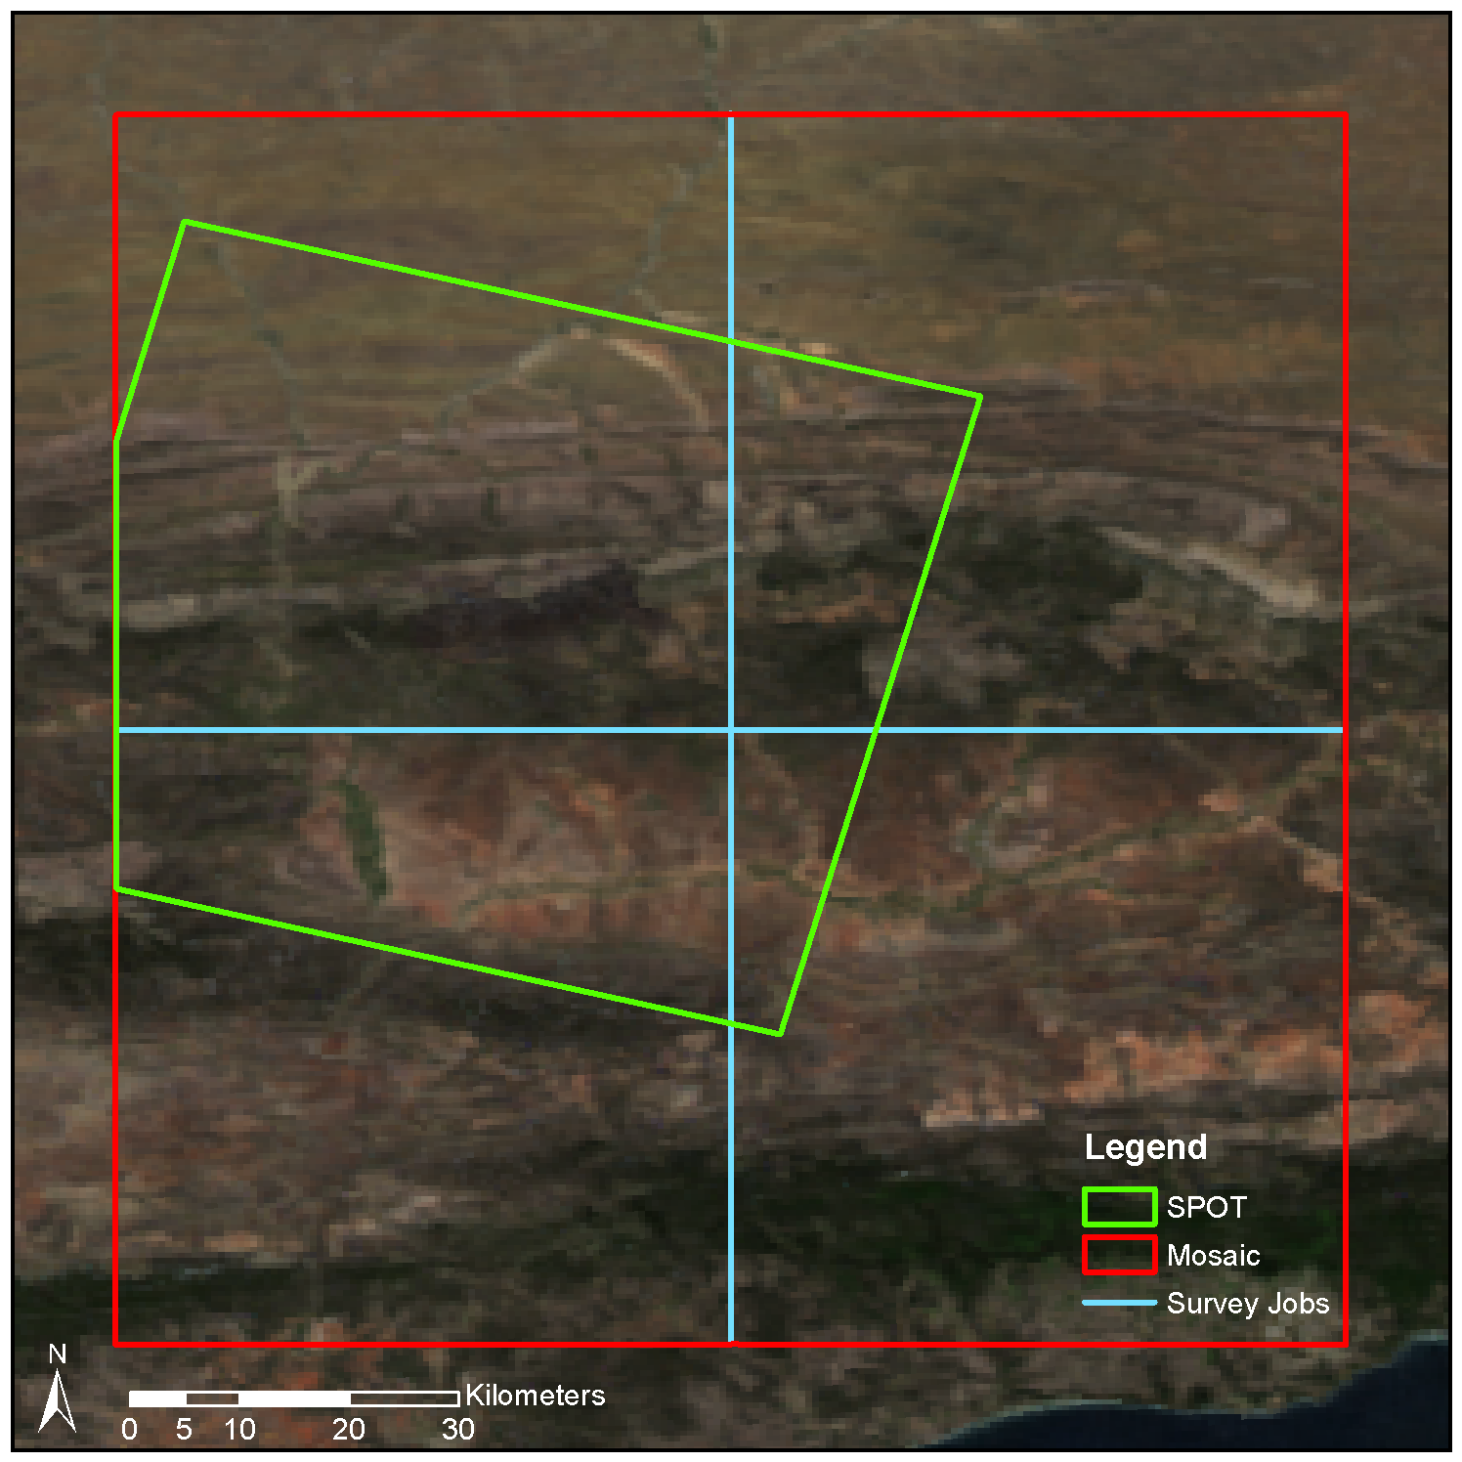

Figure 2.1 SPOT scene and mosaic extents

In the third assessment method we examined the spectral profiles of selected land cover features as represented by the bands of the uncalibrated DMC images, the corrected SPOT5 image and the calibrated DMC images (see Table ?? for a spectral comparison of spectral). The spectral signatures were compared to published spectral profiles to establish if the calibration process improved the band-to-band relationships and if the images that were corrected using the image-to-image calibration method are suitable for quantitative remote sensing.

Table 2.1 Sensor spectral bandwidths

|  |  |  |  |  |  |  |  |  |
| --- | --- | --- | --- | --- | --- | --- | --- | --- |
|  | DMC | |  | MODIS | |  | SPOT | |
|  | **Band** | **Bandwidth (nm)** |  | **Band** | **Bandwidth (nm)** |  | **Band** | **Bandwidth (nm)** |
| **Red** | - | 590 - 675 |  | 4 | 620 – 670 |  | 2 | 610 - 680 |
| **Green** | - | 500 - 650 |  | 1 | 545 – 565 |  | 1 | 500 - 590 |
| **Blue** | - | 400 - 580 |  | 3 | 459 – 479 |  | - | - |
| **Near infrared** | - | 675 - 850 |  | 2 | 841 – 876 |  | 3 | 780 - 890 |

Source: (Airbus Defence and Space 2014; NASA 2014; Intergraph 2008)

## RESULTS

### Mosaicking

Figure 2.2 shows the uncalibrated set of RGB DMC images (bordered in red), against a background of the MODIS reference image. Seam lines between adjacent DMC images and radiometric variations over the set of images are clearly visible.

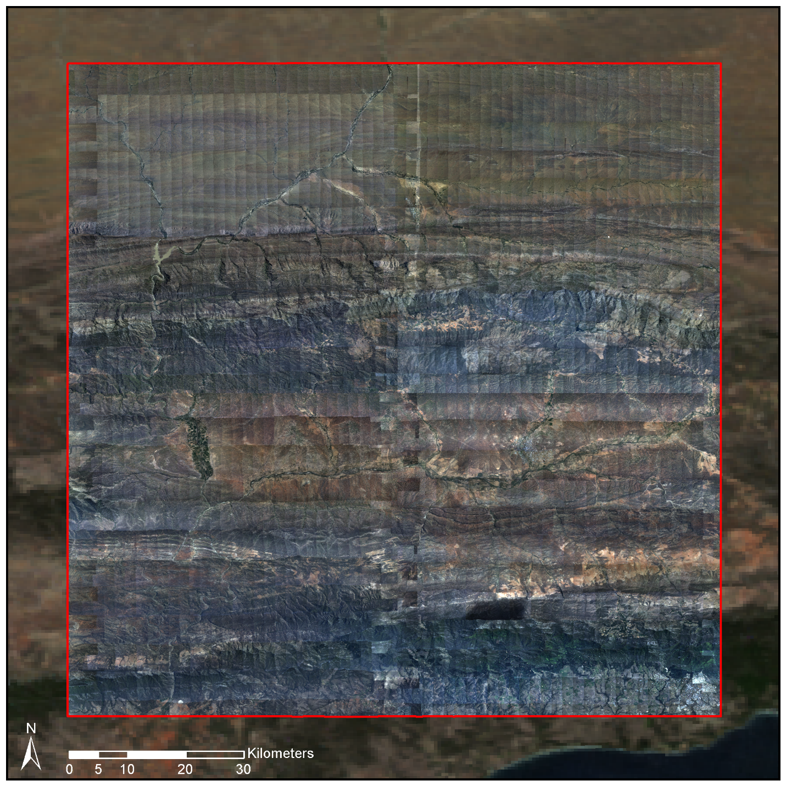

Figure 2.2 Camera calibrated mosaic on MODIS reference image background

Each DMC image was radiometrically corrected using the proposed image-to-image calibration procedure. The corrected images are shown in Figure 2.3, bordered in red, against a background of the MODIS reference image. At the scale of Figure 2.3 no seam lines or radiometric variations are apparent and the corrected images match the reflectance MODIS reference image.

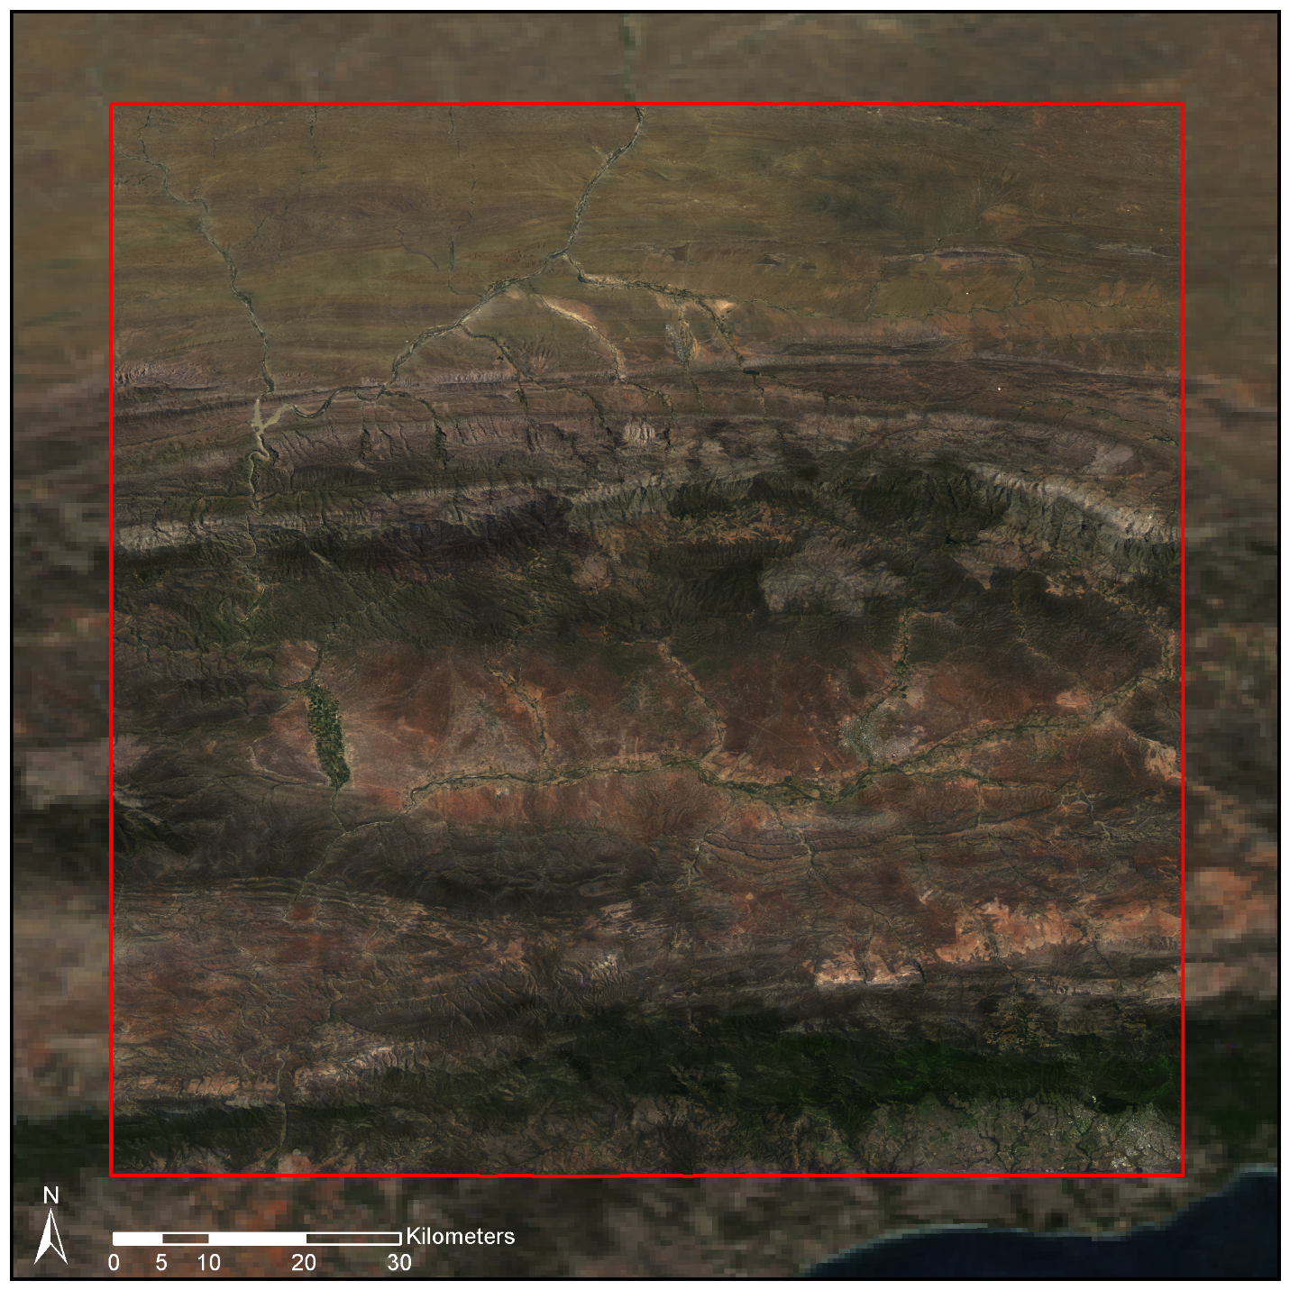

Figure 2.3 Radiometrically calibrated mosaic on MODIS reference image background

Figure 2.4a shows a single DMC image with a conspicuous hotspot (i.e. a bright area where the viewing direction approaches the sun direction (Roujean, Leroy & Deschamps 1992)) clearly visible. Figure 2.2b shows the corresponding RGB bands of the **M** raster, while Figure 2.2c demonstrates how the image-to-image cross calibration method has successfully removed the hotspot.

|  |  |  |
| --- | --- | --- |
| (a) | (b) | (c) |

Figure 2.4 Radiometric correction of hot spot image. (a) Uncalibrated image showing hot spot. (b) RGB **M** raster. (c) Calibrated image.

x

### SPOT 5 comparison

The reflectance differences between the corrected SPOT 5 image and the calibrated aerial photographs are shown in Table 2.2. A relatively low mean overall reflectance difference of 3.92% suggests that the image-to-image cross calibration method is effective and that assumptions of gradually varying atmospheric and BRDF effects are valid. The differences also compares favourably to figures reported by Collings et al. (2011) for their mosaic correction technique. The largest differences occur in the near-infrared band, likely due to dissimilarities in the near-infrared spectral responses between the MODIS, Intergraph DMC and SPOT sensors. The difference image in Figure 2.5 shows that most discrepancies occur in the rugged mountainous areas that extend west to east in the northern section of the scene and in densely vegetated areas along river banks in the southern section of the scene. On closer inspection it was found that the differences in the mountainous areas are mainly due to differing shadow effects which are likely due to variations in the time of day when the images were captured (the aerial photographs were captured throughout the day, while the SPOT 5 image was captured at ??am). The differences in the vegetated areas are attributed to the differences in the near infrared bandwidths between the MODIS, DMC and SPOT sensors (). Interestingly, no BRDF correction was performed on the SPOT imagery which implies that errors due to SPOT BRDF variations are contained in the 3.92% overall error. Spatial misalignment of the SPOT and mosaic images occurs because of inaccuracies in the orthorectification. The measured radiometric errors also contain contributions due to this spatial misalignment.

|  |  |
| --- | --- |
|  |  |
| (a) | (b) |
|  | |
| (c) | |

Figure 2.5 difference image.

Table 2.2 Mean absolute difference between calibrated SPOT 5 and DMC images

|  |  |  |
| --- | --- | --- |
| Band(s) | Mean  (% reflectance) | Std. Dev.  (% reflectance) |
| Near infrared | 5.92 | 5.17 |
| Red | 3.76 | 3.80 |
| Green | 2.94 | 2.72 |
| **All** | **3.92** | **4.02** |

x

## CONCLUSIONS

A method of radiometrically calibrating aerial photographs to surface reflectance was presented. Unlike standard sensor-to-sensor cross calibration methods, an image-to-image calibration approach was proposed in this paper. A spatially varying linear model is used to approximate the relationship between surface reflectance and sensor DN. The parameters of this model are found using a well calibrated reference image, and the model is applied to the uncalibrated imagery. A limitation of the method is that it requires a concurrent, spectrally similar reference image for any set of aerial photographs being calibrated. Such an image may not always be available at the required spatial resolution. However, the proposed method avoids the necessity of having to execute complex and time-consuming atmospheric and BRDF corrections, as well as typical mosaicking calibration techniques such as hotspot removal, colour balancing and seam line elimination.

The proposed image-to-image cross calibration method was applied to 2228 Intergraph DMC images covering an area 96 x 107km in size. A MODIS MCD43A4 image was used as the surface reflectance reference. The calibrated DMC mosaic was compared to a concurrent SPOT 5 image that was converted to surface reflectance using ATCOR software. The mean absolute reflectance difference between the DMC mosaic and SPOT 5 image was 3.92% which, given the temporal variation between the images, was considered small enough to conclude that the DMC mosaic can be used for quantitative remote sensing work. This difference also compares favourably to figures reported by Collings et al. (2011) for their mosaic correction technique.

While the results of the image-to-image cross calibration technique were surprisingly good given the simplicity of the method, many aspects warrant further investigation. Evaluation of the efficacy of using different sensors to provide the reflectance reference is of interest. Local terrain effects are poorly represented at the MODIS resolution. It would be informative to test the method with a higher spatial resolution reference such as Landsat Operational Land Imager (OLI) surface reflectance. The MISR instrument is a promising alternative to MODIS and should also be evaluated as a reflectance reference. MISR spectral bands are a better match to those of the Intergraph DMC than the MODIS bands although the resolution of the reflectance products is lower (1km). However, strong emphasis is placed on accurate calibration of the MISR data as its instrument captures data at nine different angles which allows a more accurate modelling of the BRDF compared to the kernel based approach followed in the calibration of the MODIS data (Strahler et al. 1999).

In our case study, we assumed the parameter *C* in the model of Equation (2.5) was small enough to be ignored. Some haze was however visible in the blue band, casting doubt on this assumption. It would be interesting to investigate the effect of including *C* in the model. In conjunction with this the effect of the size of the sliding window used to estimate *M* and *C* on accuracy should also be evaluated.



The image-to-image cross calibration method assumes the effect of different sensor spectral responses is linear and will be contained by the model of Equation (2.8). However, showed that the actual sensor spectral bandwidths are significantly different particularly in the near infrared region of the electromagnetic spectrum. The relatively high (5.92%) near-infrared band difference between the DMC mosaic and the SPOT 5 reflectance values and discrepancies in vegetated areas confirm this. It would be interesting to repeat the exercise of Jiang & Li (2009), where sensor measurements are simulated using typical surface reflectances to see what the real relationship between the MODIS and Intergraph DMC sensors is when the spectral response is accounted for. The accuracy of the image-to-image cross calibration method could possibly be improved by using a RTM such as 6S to better approximate the effect of differing sensor spectral responses. An initial step would need to be included in the method where the reference surface reflectances are adjusted for the uncalibrated sensor’s spectral response.

# FEATURE CLUSTERING AND RANKING

## ABSTRACT

High dimensional feature sets typically contain correlation amongst the features. Traditional feature selections approaches are prone to selection of sub-optimal features in these circumstances. A method for ranking features that is robust to correlation is presented. Average-linkage hierarchical clustering is used to group correlated features into clusters. Clusters are then ranked based on the performance of a naïve Bayes classifier on their constituent features. Individual features can then be selected from the best clusters. Problems of sub-optimality and instability of selected feature sets when using traditional methods are confirmed empirically on a vegetation mapping data set derived from aerial image pixel data. The presented method is applied to the same data. Stability of cluster rankings under different data samplings and selection criteria was shown to be significantly improved with the new method. Selected features produced good accuracies across a variety of classifiers.

## INTRODUCTION

As the number of features increases, the amount of data required to adequately represent class distributions in the increased feature space increases exponentially. This is known as the “curse of dimensionality” (Bishop 2003). For finite training samples, increasing the features beyond a certain point results in overtraining and a decrease in the classifier accuracy. This is called the “peaking phenomenon” (Jain, Duin & Mao 2000). As a rule of thumb, the number of training objects per class should be at least ten times the number of parameters required by classifier. The peaking phenomenon makes it necessary to reduce the size of the feature set to a salient minimum. While Support Vector Machine (SVM) (Burges 1998) and random forest (Breiman 2001) classifiers are becoming popular, partly because of their lack of sensitivity to the peaking phenomenon, reducing the number of features is also beneficial from the perspective of measurement costs and feature computation time. The last point is particularly relevant in large scale remote sensing studies of Very High Resolution (VHR) imagery, due to the vast quantities of data requiring processing. A further motivation for reducing features is the “ugly duckling theorem” which states that by adding a sufficient number of features, it is possible to make two arbitrary classes similar (Jain, Duin & Mao 2000).

There are two basic approaches to feature set reduction: feature selection and feature extraction. In feature extraction the feature set is mapped into a new feature space of reduced dimensionality. Various criteria can be used to define the dimensions of the new space such as separability and variance. A disadvantage of the feature extraction approach is that requires calculation of the full feature set and so does not reduce the amount of computation. Principal Components Analysis (PCA) is an example of a common feature extraction method.

Feature selection involves the selection of a subset of features from the original set according to some criterion of subset performance. The number of possible subsets increases combinatorially with the size of the feature set and it is seldom practical to evaluate all possible subsets (Jain, Duin & Mao 2000). A variety of search methods exist for reducing the portion of feature space searched. Of these, only the branch and bound method is globally optimal, the rest achieve reduced computation at the price of optimality. The complexity of the branch and bound method increases exponentially with the size of the feature set and so it is still computationally impractical for large feature sets (Jain, Duin & Mao 2000). The fastest and most straightforward search method is simply to rank features based on their individual performance and select the best *N*. The feature rankings produced as part of the classification and regression tree (CART) (Breiman et al. 1984) and random forest (Breiman 2001) classification algorithms fall under this category. CART is a method of ranking individual features based on the structure and parameters of a classification tree trained on the full feature set (Yu et al. 2006). The random forest is a classifier that can produce a feature ranking by permuting the values of a feature among the test objects and evaluating the reduction in classifier accuracy (Breiman 2001). Those features whose disturbance results in the highest reduction in accuracy are judged as being the most important.

More advanced search methods use greedy sequential approaches, such as forward selection and backward elimination. The forward selection (FS) approach starts with an empty feature set and proceeds in a number of steps where at each step, the feature from the remaining unselected features that improves an accuracy criterion the most is added to the model (Bishop 2003). The backward elimination (BE) method starts with the full set of features and removes one at each step. The feature whose removal produces the best accuracy according to some criterion is eliminated from the set at each step (Bishop 2003). BE is computationally costly and requires sufficient data to be able to train on the full feature set. The Sequential Floating Search methods SFFS and SBFS extend FS and BE by selecting and or eliminating a variable number of features at each step (Jain, Duin & Mao 2000). Greedy search methods are more likely to find the globally optimal feature set than the feature ranking approach as they are exploring more of the search space and are less inclined to select multiple correlated features.

A variety of selection criteria are used for comparing feature subsets such as measures of separability like the Mahalanobis distance or the accuracy of a specific classifier trained on the feature subset (Duin & Tax 2005). The results of feature selection are dependent on the selection criterion and search method used. A feature set that is optimal for one classifier is not necessarily optimal for another, so if using a classification criterion, one should ideally use the same classifier that will ultimately be used to label the selected features. The features selected are also dependent on the data used to evaluate the selection criterion.

The raw bands of aerial multi-spectral imagery tend to have significant spectral overlap (Intergraph 2008) and consequently are correlated with one another. As these correlated raw bands are the source data for all the derived features, and the derived feature definitions typically contain some redundancy (see Section 3.4), correlation amongst features is typical of aerial remote sensing data. In Bioinformatics, gene expression data is also recognised as typically containing a lot of correlation (Sahu & Mishra 2011; Yousef et al. 2007). A number of authors have noted difficulties in selecting features from high dimensional correlated sets. Tolosi & Lengauer (2011) show that the feature ranking produced by random forests, and other algorithms commonly used in bioinformatics, produce biased estimates of importance in the presence of correlation. A similar issue with random forests feature ranking is observed by Strobl et al. (2008). They note that less relevant features can be selected over more informative ones when there is correlation in the feature set and develop a technique to produce an unbiased feature importance measure. Yu & Liu (2004) and Yousef et al. (2007) confirm that feature redundancy can have a negative impact on the optimality of feature selection in general.

Correlation can be effectively dealt with using a feature extraction approach such as PCA but this requires computation of the full feature set. This is not practical in computationally demanding applications such as large area remote sensing of aerial imagery. A means of selecting good features in the presence of correlation was devised by Yousef et al. (2007). They use a k-means algorithm to produce a fixed number of clusters of correlated features. A backward elimination type greedy search is then conducted, eliminating whole clusters rather than individual features. The accuracy of a SVM is used as selection criterion. The clustering is then reapplied at each step. A similar method is described in Sahu & Mishra (2011), also using a k-means clustering to group correlated features. This is followed by a *t*-statistic or “Signal to Noise Ratio” (SNR) criterion to rank the clusters and select best features from each cluster. Yu & Liu (2004) use a non-linear correlation measure called symmetrical uncertainty to measure both feature relevance, by how well correlated features are with class labels, and feature redundancy, by how well correlated features are with each other. An innovative and efficient search method finds relevant features and removes redundant ones. Our method is similar in concept to those of Yousef et al. (2007), Sahu & Mishra (2011) and Tolosi & Lengauer (2011). It clusters correlated features and ranks the clusters using a simple classification accuracy measure. No prior knowledge of the number of clusters is needed however, and the clustering is only performed once.

## DATA AND GROUND TRUTH

A three class, multi-spectral pixel data set is used in this study. The pixel data originated from radiometrically corrected VHR aerial images, obtained from Chief Directorate: National Geospatial Information (NGI), a component of the South African Department of Rural Development and Land Reform. The images were captured with an Intergraph DMC camera which provides multi-spectral red, green, blue and near-infrared (NIR) bands at a 0.5m/pixel resolution. The data set was built as part of a broader vegetation mapping study being conducted in the Little Karoo, an arid region in South Africa (see Chapter 4 for details).

The three classes of interest are described in Table 3.1. The data ground truth labels were generated by visual inspection and manual delineation of objects belonging to the various classes in the images. Table 3.2 shows the total number polygons and pixels ground truthed for each class.

Table 3.1 Class descriptions

|  |  |
| --- | --- |
| Class Name | Description |
| Spekboom | *P. afra* |
| Tree | Any recognisable tree but especially the darker *Euclea* and *Pappea* trees commonly found intermingled in stands of *P. afra*. |
| Background | Bare ground, small shrubs, herbs and anything else not included in the first two classes. |

Table 3.2 Ground truth size

|  |  |  |
| --- | --- | --- |
| Class Name | Polygons | Pixels |
| Spekboom | 52 | 27260 |
| Tree | 64 | 3357 |
| Background | 44 | 182044 |
| **Total** | **160** | **212661** |

## FEATURES

The full feature set consisted of 46 features and was comprised of a typical combination of spectral features, vegetation indices and texture features. Similar features were used in Li et al. (2010) and Trias-Sanz, Stamon & Louchet (2008). The features can be separated into two broad categories: per-pixel and sliding window features. The per-pixel features are found with the spectral information from only that pixel, while the sliding window features are found from some statistic or function of the pixels inside a small local neighbourhood. The complete feature set and their labels are listed below in Table 3.3.

Table 3.3 Features

|  |  |  |
| --- | --- | --- |
| No. | Name | Description |
| 1 | R | Red |
| 2 | G | Green |
| 3 | B | Blue |
| 4 | NIR | Near-infrared |
| 5 | rN | Normalised R |
| 6 | gN | Normalised G |
| 7 | bN | Normalised B |
| 8 | nirN | Normalised NIR |
| 9 | NDVI | Normalised Difference Vegetation Index |
| 10 | RVI | Ratio Vegetation Index |
| 11-14 | tc1-4 | Tasselled cap components |
| 15-18 | pc1-4 | Principal components of raw bands |
| 19-22 | nc1-4 | Principal components of normalised bands |
| 23-26 | Entropy## | Sliding window entropy of pc1, RVI, NDVI and gN |
| 27-30 | Std## | Sliding window standard deviation of pc1, RVI, NDVI and gN |
| 31-34 | Mean## | Sliding window mean of pc1, RVI, NDVI and gN |
| 35-38 | Median## | Sliding window median of pc1, RVI, NDVI and gN |
| 39-42 | Skewness## | Sliding window skewness of pc1, RVI, NDVI and gN |
| 43-46 | Kurtosis## | Sliding window kurtosis of pc1, RVI, NDVI and gN |

Normalised colour features are defined by (Blauensteiner et al. 2006):

|  |  |  |
| --- | --- | --- |
| $$c_{i}^{n}=\frac{C_{i}}{\sum_{i=1}^{4}{C_{i}}}$$ |  | (3.1) |

Where $C_{i}$ are the raw R, G, B and NIR band values and $i$ is the band number. The denominator normalises for intensity and thus this space describes the relative contributions of the raw bands to overall intensity. The Ratio Vegetation Index (RVI) is given by

|  |  |  |
| --- | --- | --- |
| $$RVI=\frac{NIR}{R}$$ |  | (3.2) |

It has a range of zero to infinity and increases as the vegetation becomes denser and photosynthetically more active (Myneni et al. 1995). The well-known Normalised Difference Vegetation Index (NDVI) is defined as

|  |  |  |
| --- | --- | --- |
| $$NDVI=\frac{NIR-R}{NIR+R}$$ |  | (3.3) |

NDVI is limited to the range -1 to 1 and describes the same relationship as RVI but is easier to visualise and interpret due to its limited range. Both indices are invariant to intensity changes.

The tasselled cap transform of Kauth & Thomas (1976) was approximated for our problem using a principal component transform derived from the variance of the Spekboom class. This way the first component was aligned with Spekboom variation rather than wheat variation as in the original tasselled cap transform.

Entropy is a statistic that describes the amount of randomness in a variable. The entropy of the values in the image window $x$ is defined by

|  |  |  |  |
| --- | --- | --- | --- |
| $$E(x)=-\sum_{i}{h_{i}(x)}\log_{2}{h_{i}(x)}$$ |  |  | (3.4) |

Where $h_{i}(x)$ is the probability in the $i^{th}$ histogram bin of $x$. 256 bins were used in all cases.

In addition to the entropy, the median and the four central moment features (mean, standard deviation, skewness and kurtosis) of (Li et al. 2010) were included as sliding window features. The first principal component, RVI, NDVI and normalised green channel were all used as inputs to the sliding window feature set. A sliding window size of five pixels was used.

## METHOD

Our method is described as follows:

1. Perform average-linkage hierarchical clustering (Szekely & Rizzo 2005) of the feature set using the correlation coefficient as the dissimilarity metric.
2. Select a natural number of clusters containing high correlation by visual inspection of the dendrogram.
3. Rank each cluster’s importance by finding the accuracy of a naïve Bayes classifier trained on each individual feature and then finding the median of the feature accuracies in the cluster.
4. Select a single feature from each of the *N* clusters with best importance scores.

Hierarchical clustering provides a simple way of clustering the features that does not require prior knowledge of the number of clusters. It starts with each individual feature in its own cluster and proceeds in a number of steps where the pair of clusters that minimise a criterion are merged at each step. The dendrogram is graphical representation of this process. The average linkage criterion is the average dissimilarity over all pairs of objects in the two clusters.

Cluster stability and strength of correlation within each cluster are the key factors to consider when choosing the number of clusters and can be visually interpreted from the dendrogram. The naïve Bayes classifier was chosen to evaluate importance primarily because it makes no assumptions about the form of the class distributions and can thus provide a generic measure of separability. It is simple, fast and recognised as being accurate for a variety of problems (Hand & Yu 2001). The “naïve” assumption of feature independence is of no consequence when testing individual features. These justifications aside, our reasoning for the choice of dissimilarity metric, clustering algorithm and selection criterion is loose and other options could be also be effective.

The number of clusters, *N*, can be specified by the user based on the size of the training set or chosen using a grid search with the final classifier accuracy as performance measure. To avoid biased accuracy estimates, all classifier accuracy evaluation, for cluster ranking or selection of *N*, is done on unseen test data using a ten-fold cross validation (Bishop 2003). Major benefits of the cluster ranking method are its speed and that it allows hand-picking of the single features that represent each cluster. The flexibility to choose features allows the user to favour those features that are fastest to compute or perhaps to choose those features that are more readily understood. If these factors are not of importance, the highest individually ranked feature in each cluster can be chosen.

## RESULTS AND DISCUSSION

### Standard Feature Selection

We evaluated the sensitivity of standard feature selection approaches to different disturbances using the vegetation mapping data set. The size of the Background class was reduced to be the same as the Spekboom class by taking a random subsample. This was done to expedite computation times.

In the first experiment, a forward selection procedure with naïve Bayes classification accuracy as selection criterion was repeated on bootstrapped samples of the original data. The first six selected features are shown in Table 3.4 for five different data samplings. The first selected feature remains stable but the rest of the features are sensitive to the specific data set used to evaluate importance. This variation occurs in spite the fact that data contains more than sufficient samples to be representative of the real class distributions.

Table 3.4 Experiment 1: Forward selection results for different data sets

|  |  |  |  |  |  |  |
| --- | --- | --- | --- | --- | --- | --- |
| Sample Num. | Selected Features (Ordered by ranking) | | | | | |
| 1 | pc2 | tc4 | pc1 | SkewnessNDVI | StdRVI | rc3 |
| 2 | pc2 | rc3 | EntropyPc1 | KurtosisPc1 | SkewnessGn | KurtosisGn |
| 3 | pc2 | rc3 | MeanPc1 | StdGn | MedianRVI | KurtosisNDVI |
| 4 | pc2 | tc4 | EntropyPc1 | StdRVI | pc3 | MeanRVI |
| 5 | pc2 | rc3 | EntropyPc1 | KurtosisGn | SkewnessGn | SkewnessPc1 |

Next, the sensitivity to the selection criterion was evaluated by running a forward selection procedure with following criteria: inter–intra class distance, sum of Mahalanobis distances and the accuracies of naïve Bayes, decision tree and normal Bayes classifiers. Results in Table 3.5 show significant variation in the first six selected features, although certain features such as pc2, MeanPc1 and MedianPc1 are favoured by differing criteria.

Table 3.5 Experiment 2: Forward selection results for different selection criteria

|  |  |  |  |  |  |  |
| --- | --- | --- | --- | --- | --- | --- |
| Criterion | Selected Features (Ordered by ranking) | | | | | |
| Inter-intra | rN | NIR | rc3 | R | StdRVI | StdNDVI |
| Mahalanobis | MedianNDVI | rc3 | MeanPc1 | pc2 | pc4 | StdRVI |
| Naïve Bayes | pc2 | rc3 | MedianPc1 | SkewnessPc1 | KurtosisGn | KurtosisPc1 |
| Decision tree | pc2 | MedianGn | MedianPc1 | pc4 | MeanRVI | EntropyGn |
| Normal Bayes | pc2 | gN | MeanPc1 | rc3 | StdRVI | MeanNDVI |

Finally, common subset search methods were tested for their effect on selected features. All except the random forest used a naïve Bayes classification accuracy as selection criterion. It was not practical to evaluate the branch and bound method due to the computation time required. Variation in selected features is again significant and of such a degree that it is difficult to discern any consistency. Results are presented in Table 3.6.

Table 3.6 Experiment 3: Feature selection results for different search methods

|  |  |  |  |  |  |  |
| --- | --- | --- | --- | --- | --- | --- |
| Search Method | Selected Features (Ordered by ranking) | | | | | |
| FS | pc2 | rc3 | EntropyPc1 | SkewnessPc1 | KurtosisPc1 | SkewnessGn |
| BE | NIR | tc4 | rc1 | rc3 | EntropyPc1 | MedianNDVI |
| Individual ranking | pc2 | MeanNDVI | MedianNDVI | rN | NDVI | rc1 |
| Random forest | rN | StdRVI | tc4 | MedianPc1 | bN | MedianGn |

### Clustering and Ranking

The seemingly inexplicable variation in results of standard feature selection methods suggests that results are suboptimal. The likely cause of the instability is redundancy in our feature set. When doing feature selection with correlated features on overlapping problem, results can appear somewhat random as no particular feature makes a big impact and many are similar to each other. The effectiveness of the feature clustering and ranking method was tested on the vegetation mapping data. The dendrogram showing the clustering of the feature set is plotted in Figure 3.1. The line in red shows the correlation threshold value at which the feature clusters were extracted. This point was selected as a relatively stable point in the hierarchy and one where the correlation amongst features is strong.



Figure 3.1 Clustering of correlated features

The clusters were ranked using the naïve Bayes classification accuracy criterion. Table 3.7 lists the clusters ordered by their importance, with their component features. This table reveals a number of interesting properties of the features. Firstly, it is clear that there is a significant amount of correlation amongst the features in general. The correlation between raw R, G, B and NIR bands is surprisingly strong and these are all grouped into a single cluster. While the definitions of the nirN, NDVI and RVI features are quite different, they are all describing the same spectral property of vegetation, namely high absorption in the red band and high reflectance in the NIR band. This is confirmed by their collection in the same cluster. The mean sliding window feature, median sliding window feature and source feature operated on by those sliding windows are strongly correlated with each other as one would expected.

Table 3.7 Ranked clusters

|  |  |  |
| --- | --- | --- |
| Num. | Importance (%) | Features |
| 1 | 68.27 | rN, nirN, NDVI, RVI, tc2, pc2, rc1, MeanRVI, MedianRVI, MeanNDVI, MedianNDVI |
| 2 | 61.38 | R, G, B, NIR, tc1, pc1, MeanPc1, MedianPc1 |
| 3 | 60.41 | EntropyPc1 |
| 4 | 55.23 | gN, MeanGn, MedianGn |
| 5 | 54.52 | bN |
| 6 | 53.57 | rc2, rc4 |
| 7 | 50.57 | tc4, rc3 |
| 8 | 49.34 | pc4 |
| 9 | 47.93 | EntropyRVI, StdRVI, EntropyNDVI, StdNDVI |
| 10 | 43.96 | StdPc1 |
| 11 | 43.62 | EntropyGn, StdGn |
| 12 | 42.65 | tc3, pc3 |
| 13 | 41.29 | SkewnessRVI, SkewnessNDVI |
| 14 | 35.27 | SkewnessGn |
| 15 | 35.19 | KurtosisRVI, KurtosisNDVI |
| 16 | 35.03 | SkewnessPc1 |
| 17 | 34.86 | KurtosisGn |
| 18 | 33.86 | KurtosisPc1 |

The first two experiments of Section 3.6.1 were repeated with the feature clustering and ranking method, to compare its stability to that of standard methods. The effect of different bootstrap samples of the data set on the ranking of the top six clusters in shown in Table 3.8. The clusters are referred to by their numbers as shown in the first column of Table 3.7. Clusters 1 to 5 are consistently selected for all data samplings and cluster 6 is selected for all but one of the tests. This is a significant improvement in stability compared to the corresponding results from forward selection in Table 3.4.

Table 3.8 Experiment 4: Feature clustering and ranking results for different data sets

|  |  |  |  |  |  |  |
| --- | --- | --- | --- | --- | --- | --- |
| Sample Num. | Selected Clusters (Ordered by ranking) | | | | | |
| 1 | 1 | 2 | 3 | 4 | 5 | 7 |
| 2 | 1 | 2 | 3 | 5 | 4 | 6 |
| 3 | 1 | 2 | 3 | 4 | 5 | 6 |
| 4 | 1 | 2 | 3 | 4 | 5 | 6 |
| 5 | 1 | 2 | 3 | 4 | 5 | 6 |

Table 3.9 shows the resulting clusters for different selection criteria. Some variation in cluster ranking is seen for different criteria and this not unexpected as the criteria obviously view cluster importance differently. Results are nevertheless substantially more consistent than the equivalent experiment in Section 3.6.1 where no single feature was selected for all criteria. Here clusters 1, 2, 3, 5 and 6 are consistently part of the top six for the differing criteria.

Table 3.9 Experiment 5: Feature clustering and ranking results for different selection criteria

|  |  |  |  |  |  |  |  |
| --- | --- | --- | --- | --- | --- | --- | --- |
| Criterion | Selected Clusters (Ordered by ranking) | | | | | | |
| Inter-intra | | 1 | 5 | 6 | 3 | 2 | 9 |
| Mahalanobis | | 1 | 5 | 6 | 2 | 3 | 7 |
| Naïve Bayes | | 1 | 2 | 3 | 4 | 5 | 6 |
| Decision tree | | 1 | 2 | 3 | 4 | 5 | 7 |
| Normal Bayes | | 1 | 2 | 6 | 3 | 5 | 4 |

We selected the features NDVI, pc1, EntropyPc1, gN, bN and rc2 from the top six clusters of Table 3.7. Selection of sliding window features was avoided where possible as they are computationally more demanding than the per-pixel features. There is only one sliding window feature, EntropyPc1 in our final selection. This makes for a very significant improvement in computation time over the full feature set. Decision tree, random forest, Support Vector Machine (SVM) and K-Nearest-Neighbour (KNN) classifiers were trained and tested on the selected features using a ten-fold cross validation. Results are given in Table 3.10. Similarly good performances are obtained across all classifiers, confirming the value of the selected features.

Table 3.10 Classifier performance comparison

|  |  |  |  |  |
| --- | --- | --- | --- | --- |
| Classifier | 3 Class Error (%) | CA (Bg / Sb / Tr)a | PA (Bg / Sb / Tr)a | Kappa |
| Decision Tree | 9.46 | 97.64 / 98.10 / 46.86 | 91.22 / 94.49 / 85.91 | 0.87 |
| Random Forest | 9.16 | 98.72 / 97.51 / 47.97 | 89.66 / 96.96 / 85.91 | 0.88 |
| KNN | 10.45 | 97.27 / 97.49 / 80.27 | 97.08 / 98.82 / 72.74 | 0.94 |
| SVM | 10.58 | 97.17 / 95.33 / 79.73 | 94.44 / 98.69 / 75.12 | 0.92 |

a CA = Consumer’s Accuracy (%), PA = Producer’s Accuracy (%), Bg = Background, Sb = Spekboom, Tr = Tree

## CONCLUSIONS

Correlation amongst features was identified as a source of instability and inaccuracy in feature selection. A method for ranking correlated clusters of features was presented. Using hierarchical clustering, a natural number of clusters can be selected by observing the stability of correlation relationships in the data using a dendrogram. Clusters are then ranked using an importance measure, calculated as the median of the accuracy of a naïve Bayes classifier trained on each individual feature in the cluster. By selecting individual features from the best clusters, a set of informative features is found while simultaneously removing correlation from the data. The ability to hand-pick features is beneficial as it allows other factors to be included in determining the optimal feature set such as speed of computation and physical interpretability.

Experiments were conducted on a three class vegetation mapping data set consisting of 46 features derived from VHR multi-spectral image pixel data. There was a large amount of correlation amongst the features. It was shown that features selected using a standard forward selection approach were sensitive to different data samplings and selection criteria. Various standard search methods were also found to select vastly different groups of features. Using feature clustering and ranking, selected features were substantially more consistent under different data samplings and different selection criteria. The selected features also produced good accuracies on a variety of classifiers.

A possible weakness in the presented method is the formulation of the importance measure. The clusters are evaluated in isolation which makes selection susceptible to sub-optimality as the best individual clusters are not necessarily the best collectively (Cover 1974). Ideally the importance of clusters should be evaluated in the context of other clusters so that the effect of informative relationships is incorporated into the ranking. One option would be to follow a backward elimination type approach similar to Yousef et al. (2007). Alternatively, using the random forest concept of feature importance, we suggest the following as a simple and efficient approach that does not require training on the complete set of features:

1. Find the first principal component of each cluster’s features. Use this as a representative feature for that cluster.
2. Train a naïve Bayes classifier on the full set of representative features and find its accuracy.
3. For each cluster, permute that cluster’s representative feature amongst the samples in the test set and find the accuracy of the naïve Bayes classifier on the disturbed set.
4. The decrease in accuracy between steps 2 and 3 becomes the importance measure for that cluster.

Another aspect of our method that could benefit from further investigation is the correlation coefficient dissimilarity metric. While non-linear relationships between features were captured by this linear measure in our experiments (for example the relationship between RVI and NDVI), this will not always be the case. It would be preferable to use a metric that can describe non-linear correlation, such as the symmetrical uncertainty used in Yu & Liu (2004).

# VERY HIGH RESOLUTION MAPPING OF *PORTULACARIA AFRA* CANOPY COVER

## ABSTRACT

Very high resolution canopy cover maps of *P. afra* are required to assist with restoration of degraded habitat in the Little Karoo. Variations in habitat and level of degradation, in addition to radiometric variations in the imagery, make this a challenging problem. High resolution remote sensing of vegetation over large spatial extents has not received much attention, especially in arid areas. Here we present a per-pixel classification approach for canopy cover mapping of *P. afra*. Multi-spectral 0.5m resolution aerial imagery was obtained from Chief Directorate: National Geospatial Information and radiometrically corrected using a cross calibration technique. Ground truth was produced by selecting and hand labelling polygons in the imagery. A feature clustering and ranking procedure that is robust to correlation amongst features was applied to select an informative feature subset from a typical set of spectral, textural and vegetation index features. Support Vector Machine (SVM), random forest, decision tree, K-Nearest Neighbour (KNN) and Bayes normal classifiers were evaluated against both the hand labelled image ground truth and canopy cover ground truth acquired at 20 field sites. All classifiers except the Bayes normal classifier performed similarly well. The decision tree produced the best results on the field ground truth and was chosen as the final classifier. It produced a mean absolute canopy cover error of 5.85% with a standard deviation of 4.65% on the field ground truth. These results compare favourably with similar studies. Visual inspection of the canopy cover map showed good overall accuracy with some sensitivity to habitat variation.

## INTRODUCTION

*Portulacaria afra* (Spekboom) is an evergreen succulent tree growing to 2.5m, with a dense canopy of small fleshy leaves. It occurs in the Subtropical Thicket biome in the semi-arid Eastern Cape and Little Karoo regions in South Africa (Vlok, Cowling & Wolf 2005). “The Subtropical Thicket habitat types are most easily recognized by the occurrence of woody trees, spinescent shrubs and a relative abundance of succulents. When occurring as solid stands the vegetation can form impenetrable dense thickets, but this is uncommon in the Little Karoo. In most of the area the Subtropical Thicket vegetation occurs as discrete bush-clumps, usually in a matrix of Succulent Karoo vegetation” (Vlok, Cowling & Wolf 2005: 41). While *P. afra* is tolerant of browsing by indigenous herbivores, it is highly susceptible to over browsing by goats (Marais, Cowling & Powell 2009; Sigwela et al. 2009; Mills et al. 2007; Mills et al. 2005). Poorly managed goat grazing has transformed thicket over much of its range into sparsely scattered thicket clumps, isolated trees and a covering of herbs (Mills et al. 2005).

There is considerable interest in actively restoring degraded thicket habitat. *P. afra* is unusually effective at storing carbon for an arid region. Its carbon storage capacity competes with that of mesic forests (Mills et al. 2005). Subtropical Thicket provides an important source of food for many herbivores, including domesticated livestock (Thompson et al. 2009; Vlok, Cowling & Wolf 2005). Re-establishment of *P. afra* in degraded areas will reduce erosion, reduce flood severity and improve water quality (Van Luijk et al. 2013; Mills & Cowling 2006). It is also attractive from an employment perspective; potentially creating thousands of jobs in impoverished areas, if implemented on a large scale.

The dense canopy of *P. afra* facilitates an accumulation of soil organic matter which in turn significantly improves the water-holding capacity and fertility of the soil (Adie & Yeaton 2013; Mills & Cowling 2010; Lechmere-Oertel et al. 2008; Mills & Fey 2004). The provision of shade, improved soil quality and moisture retention, creates a favourable environment for other plants to germinate (Adie & Yeaton 2013; Mills & Cowling 2010). It has been observed that over a period of 40 to 50 years, woody canopy and other species re-establish in *P. afra* restoration areas to a degree that restored thicket is compositionally comparable to intact thicket (Van der Vyver et al. 2013).

*P. afra* canopy cover maps are required to assist in the restoration process. Canopy cover measurements are currently being done by visual inspection in the field. There is a need for greater accuracy and repeatability than is possible with this technique. One of the factors informing the identification of candidate restoration areas is the level of degradation. This can be estimated from the existing canopy cover and measures of intact canopy cover in a similar habitat to the restoration area. Measures of intact canopy cover also provide a guide as to an appropriate planting density. Restoration progress can be monitored by updating the canopy cover map over time. Canopy cover represents a first step towards being able to remotely sense biomass (Eisfelder, Kuenzer & Dech 2012; Suganuma et al. 2006; Ludwig, Reynolds & Whitson 1975), which would assist in the carbon accounting required for trading credits on the international market (Mills et al. 2010). It would also allow the estimation of expected carbon storage resulting from restoration which would provide an indication of the economic feasibility of restoration. A canopy cover map would also be a useful tool for deepening the present understanding of the Subtropical Thicket biome.

Thompson et al. (2009) conducted a degradation mapping study in the Little Karoo. A detailed 1:50000 vegetation map of the Little Karoo developed by Vlok, Cowling & Wolf (2005), was used to delineate different habitats so they could be treated separately. The degradation levels of Subtropical Thicket were derived by thresholding MODIS NDVI data. North and south facing slopes were treated separately to account for the different densities of *P. afra* in these topographies. To exploit the relative greenness of *P. afra* compared to the background vegetation, data from the September growing season was used for the thresholding. This NDVI data was averaged over two years. The study was successful at estimating intact, moderate and severe degradation levels of *P. afra* thicket at the MODIS resolution of 250m.

Currently, there is an initiative to involve private land-owners in restoration in order to broaden its impact (Curran et al. 2012; Mills et al. 2010). Maps at a pixel resolution of 1.5m or smaller are required to provide sufficient spatial detail for working with expected stand sizes of the order of 50 hectares. To achieve sufficient accuracy for carbon storage estimations, it will be necessary to estimate canopy cover in finer detail than the three levels of degradation used in Thompson et al. (2009). Our work aims to meet these requirements by accurately mapping *P. afra* canopy cover at a spatial resolution of 0.5m.

## STUDY AREA

The Little Karoo as defined in Vlok, Cowling & Wolf (2005), is a semi-arid region of great biodiversity lying between two mountain ranges. Three biomes considered to be biodiversity hotspots of global significance intersect in the Little Karoo (Thompson et al. 2009). 54 habitat types were identified by Vlok, Cowling & Wolf (2005) in their vegetation map, of which ten support *P. afra*. The Subtropical Thicket biome makes up 35.3% of the Little Karoo which has a total area of 2 343 900 ha (Vlok, Cowling & Wolf 2005). It was found that 89.3% of the *P. afra* thicket was degraded to some extent in an area comprising roughly half of the Little Karoo (Thompson et al. 2009). The Little Karoo is an interesting study area because it contains a significant portion of *P. afra* suited and degraded habitat and has been targeted for restoration. A representative portion was chosen as the study area, as shown in Figure 4.1. This area includes examples of all the different biomes and nine of the ten habitat types supporting *P. afra* as defined by Vlok, Cowling & Wolf (2005). Figure 4.2 shows a study area map of the different habitats supporting *P. afra*.



Figure 4.1 Little Karoo study area

## DATA AND GROUND TRUTHING

We acquired VHR aerial imagery of the study area from Chief Directorate: National Geo-spatial Information (NGI), a component of the South African Department of Rural Development and Land Reform. The images are captured at a 0.5m/pixel resolution with an Intergraph DMC camera which provides multi-spectral red, green, blue and near-infrared (NIR) bands. The imagery for our study area consists of 2228 images acquired over multiple days from 22 January to 8 February 2010. While the imagery provided by NGI is orthorectified, it has no radiometric corrections applied to it. The NGI imagery contains significant variations due to BRDF effects, atmospheric effects and viewing geometry which make it poorly suited to quantitative remote sensing techniques. We calibrated the imagery to surface reflectance, correcting for coarse scale atmospheric and BRDF effects, using the method described in Chapter 2. Calibration to an absolute physical quantity such as reflectance is beneficial as this is an invariant property of the surface. It also allows the data to be used in physical models and fused or otherwise used in combination with other calibrated data sources and used in multi-temporal studies. Radiometric calibration is important for our study as it allows accurate snapshot mapping over a large spatial area as well as provides the possibility of repeating the canopy cover mapping over time to evaluate restoration progress.

Canopy cover ground truth was acquired in the field at 20 different sites, each of roughly one hectare. A botanist with significant experience in the area provided expertise in the selection of sites to encompass variation in geology, habitat and level of degradation. Boundary polygons, were recorded for each site by walking the perimeter with a DGPS device. These were post-processed to provide sub one meter accuracy. Estimates of canopy cover inside the polygons were established visually and reference photos captured. The locations of the ground truth sites and their corresponding area names are shown in Figure 4.2. Details of the mosaic vegetation, geology and measured canopy cover for each site are given in Table 4.1. A three level degradation measure, as used in (Thompson et al. 2005), is reported for each site. The canopy cover measures were made in the field as a range between minimum and maximum values, spanning at most ten percent. The midpoint between these minimum and maximum values is reported in Table 4.1. This data set is referred to as the “field ground truth”. Figure 4.3 shows an example of a ground truth polygon on a background of the NGI imagery, rendered in RGB.

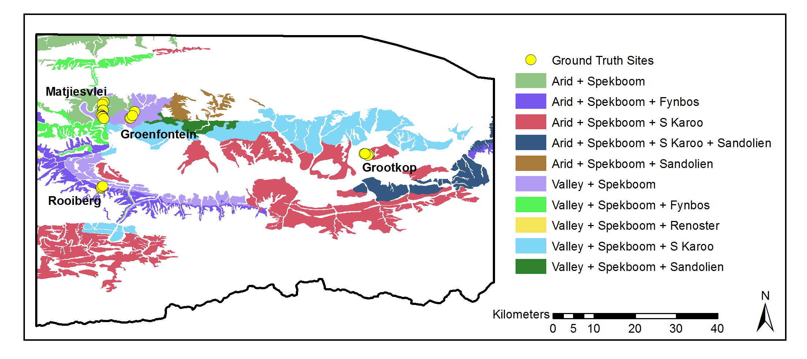

|  |  |
| --- | --- |
| Figure 4.2 Study area *P. afra* habitats and field ground truth sites | Source: (Vlok, Cowling & Wolf 2005) |

Table 4.1 Field ground truth site information

|  |  |  |  |  |  |
| --- | --- | --- | --- | --- | --- |
| Area | Number | Geology | Mosaic | Degradation | Cover (%) |
| Matjiesvlei | 1a | Shale | Arid Spekboom | Pristine | 6.0 |
|  | 1b |  |  | Pristine | 22.5 |
|  | 2 |  |  | Pristine | 70.0 |
|  | 3 |  |  | Pristine | 85.0 |
|  | 4 |  |  | Pristine | 65.0 |
|  | 5 |  |  | Pristine | 37.5 |
|  | 6 |  |  | Pristine | 17.5 |
|  | 7 |  |  | Pristine | 15.0 |
|  | 8 |  |  | Pristine | 2.0 |
| Groenfontein | 1 | Shale | Arid Spekboom | Severe | 0.0 |
|  | 2 |  |  | Severe | 4.0 |
|  | 3 |  |  | Severe | 10.0 |
|  | 4 |  |  | Moderate | 25.0 |
| Grootkop | 1 | Enon Conglomerate | Succulent Karoo | Pristine | 22.5 |
|  | 2 |  |  | Severe | 0.5 |
|  | 3 |  |  | Moderate | 42.5 |
|  | 4 |  |  | Pristine | 77.5 |
| Rooiberg | 1 | Sandstone | Fynbos | Pristine | 20.0 |
|  | 2 |  |  | Moderate | 11.0 |
|  | 3 |  |  | Severe | 0.0 |

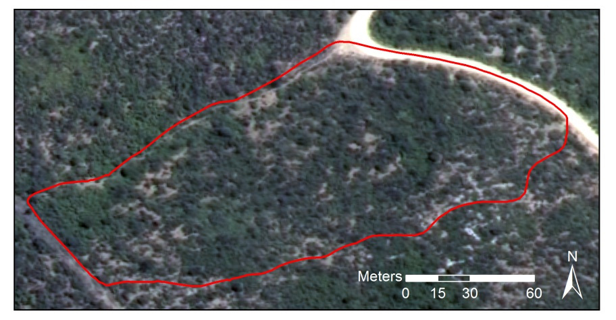

Figure 4.3 Matjiesvlei2 ground truth site

Table 4.2 Class descriptions

|  |  |
| --- | --- |
| Class Name | Description |
| Spekboom | *P. afra* |
| Tree | Any recognisable tree but especially the darker *Euclea* and *Pappea* trees commonly found intermingled in stands of *P. afra*. |
| Background | Bare ground, small shrubs, herbs and anything else not included in the first two classes. |

We adopted a labelling scheme of three classes as described in Table 4.2. While canopy cover mapping is in essence a two class problem (*P. afra* and everything else), the addition of the third Tree class provided a number of advantages in designing the classifier. By merging multiple classes into a single class, the ability to adjust the priors of individual merged classes is lost. The class priors, or “weights”, control the relative emphasis the classifier places on identifying each class correctly (Mingguo, Qianguo & Mingzhou 2009). The differentiation of *P. afra* from trees is a particularly challenging part of the problem due to their spectral and textural similarity. Thus the addition of the Tree class is useful, as it allows control over the classification accuracy of trees relative to the other classes. The descriptive power or complexity of the classifier is also improved by including the extra class, given sufficient training data. Rather than modelling only two classes, the classifier is now modelling three classes which improves its ability to approximate complex decision boundaries, especially in the vicinity of the problematic Tree - Spekboom overlap. It can be seen as a kind of classifier combination where multi-modal data is handled with a combination of per-mode classifiers (Jain, Duin & Mao 2000). Finally, the additional class provides greater diagnostic detail on the performance of the classifier. For instance, in the three class confusion matrix, it can be seen if Spekboom is primarily being misclassified as Background or as Tree. This diagnostic information is useful in adjusting classifier parameters to improve performance.

Classifier training data was obtained by visual discrimination and hand labelling of images. RGB and CIR images were used side by side in this exercise. Objects belonging to the various classes were delineated with polygons as shown in Figure 4.4. Only objects where there was a reasonable degree of confidence of class membership were included in the ground truth. Despite this, it is unavoidable that the ground truth contains some inaccuracies as it is not always easy to visually distinguish between the different classes. Areas were selected to encompass variability in habitat and level of degradation. This ground truth was however limited to the four images containing the field ground truth of Table 4.1. The total number polygons and pixels ground truthed for each class is shown in Table 4.3. This data set is referred to as the “image ground truth”.



Figure 4.4 Hand labelled ground truth

Table 4.3 Image ground truth size

|  |  |  |
| --- | --- | --- |
| Class Name | Polygons | Pixels |
| Spekboom | 52 | 27260 |
| Tree | 64 | 3357 |
| Background | 44 | 182044 |
| **Total** | **160** | **212661** |

## METHODOLOGY

We followed a statistical pattern recognition approach to classify *P. afra* canopy. Our pixel size of 0.5m, combined with the tendency of *P. afra* to grow in continuous stands meant that there was little spectral mixing and pixels covering *P. afra* were relatively pure. This supported a hard per-pixel classification approach as opposed to a soft classification (Xu et al. 2005) or regression type approach that is often used in biomass estimation (Eisfelder, Kuenzer & Dech 2012; Lu 2006). The fractional canopy cover was then determined as the portion of pixels classified as *P. afra* over an area of interest. Object based approaches to image classification, where homogenous objects are first segmented and then classified as a whole, are receiving a lot of attention. These approaches are often favoured for VHR imagery because they are potentially able to better exploit the additional spatial information and deal with unwanted variation when compared to the more traditional per-pixel approach (Yu et al. 2006; Carleer, Debeir & Wolff 2005). The segmentation problem is however recognised as being poorly posed, requiring manual adjustment of parameters and being difficult to solve robustly (Baraldi et al. 2010). We followed a pixel based approach as this gave us adequate accuracy and avoided the complexities and computation time associated with segmentation. Some vegetation has distinctive phenological variations which can be a useful source of information in distinguishing different species or measuring characteristics of a habitat such as degradation (Thompson et al. 2009). We were limited to a snapshot approach as there was only one set of aerial imagery available from NGI at the time of writing.

## FEATURES

*P. afra* has a characteristic lime green colour is evergreen. Somewhat fortuitously, the NGI imagery was captured in January, which is in the Little Karoo’s dry season. This helped contrast the evergreen *P. afra* against the relatively drier background vegetation. In a relatively undisturbed state, it grows in clumps consisting of many shrubs, interspersed with occasional trees such as *Pappea* and *Euclea*. A set of 46 features that would aid in describing these visual characteristics of *P. afra* were evaluated. The set included a fairly typical combination of spectral features, vegetation indices and texture features. Similar features have been used in Li et al. (2010) and Trias-Sanz, Stamon & Louchet (2008).

The features we used can be separated into two broad categories: per-pixel and sliding window features. The per-pixel features are found with the spectral information from only that pixel, while the sliding window features are found from some statistic or function of the pixels inside a small local neighbourhood. The sliding window features describe some aspect of the relationship between a small neighbourhood of pixels. While the spectral resolution of the VHR imagery is poor, the spatial resolution allows description of vegetation structure and spatial patterns that is not possible with lower resolution satellite imagery. Texture is recognised as an important feature in biomass estimation in complex habitats (Singh, Malhi & Bhagwat 2014; Lu 2006). The sliding window features were included to try and exploit this source of information in distinguishing our classes. We could not include common texture features such as statistics of the Gray Level Co-occurrence Matrix (GLCM) or the occurrence histograms of Local Binary Patterns (LBP). To be representative, these texture features need to be calculated from a greater number of pixels than is practical with a sliding window. Typically they are evaluated per region and thus require an object based approach.

The colour of an object is defined by the shape of its reflectance spectrum while the intensity is defined by the spectral amplitude. The dimensions of the raw RGB colour space are coupled with intensity. Colour is captured by the relative amounts of the raw colour bands rather than their absolute values. Normalised colour features are defined by (Blauensteiner et al. 2006):

|  |  |  |  |  |
| --- | --- | --- | --- | --- |
| $$c_{i}^{n}=\frac{C_{i}}{\sum_{i=1}^{4}{C_{i}}}$$ |  |  |  | (4.1) |

Where $C_{i}$ are the raw R, G, B and NIR band values and $i$ is the band number. The denominator normalises for intensity and thus this space describes the relative contributions of the raw bands to overall intensity. While we have calibrated the imagery to surface reflectance, this was done at a coarse spatial scale and variations in intensity remain at a fine resolution. This normalised colour space will assist in further removing intensity variations not removed by the calibration. The HSV space serves a similar purpose, but was not used as the H (hue) dimension is angular and thus has a discontinuity between 0o and 360o. This is problematic for distance measures or modelling of class distributions in pattern recognition.

Green, living vegetation absorbs light in the Photosynthetically Active Radiation (PAR) region of the spectrum which corresponds to the red band. There is a sharp transition from absorption to reflection around 700nm (Gates 1980). Vegetation is highly reflective in the near infra-red band as the energy in these wavelengths is insufficient for photosynthesis and potentially harmful due to its heating effects. Various vegetation indices exploit these spectral properties. The Ratio Vegetation Index (RVI) is given by:

|  |  |  |
| --- | --- | --- |
| $$RVI=\frac{NIR}{R}$$ |  | (4.2) |

It has a range of zero to infinity and increases as the vegetation becomes denser and photosynthetically more active (Myneni et al. 1995). The well-known Normalised Difference Vegetation Index (NDVI) is defined as

|  |  |  |
| --- | --- | --- |
| $$NDVI=\frac{NIR-R}{NIR+R}$$ |  | (4.3) |

NDVI is limited to the range -1 to 1 and contains the same information as RVI but is easier to visualise and interpret due to its limited range. Both indices are invariant to intensity changes.

The tasselled cap transform is a linear transform of the raw band feature space to a new orthogonal co-ordinate system, similar to a principal component transform. It was designed for agricultural wheat classification and was intended to reduce variability in soil and wheat classes by removing variation due to topography, sun angle and wheat growth stage (Kauth & Thomas 1976). The tasselled cap transform was approximated for our problem using a principal component transform derived from the variance of the Spekboom class. This way the first component was aligned with Spekboom variation rather than wheat variation as in the original tasselled cap transform. As it is simply a rotation of the raw band space, its usefulness is as a dimensionality reduction technique similar to PCA, rather than as an extractor of novel features. The principal components of the normalised colours of Equation (4.1) were also included to capture texture arising from colour variation.

Entropy is a statistic that describes the amount of randomness in a variable. It was included in our feature set as a texture feature to describe complexity in the local neighbourhood of a sliding window. The entropy of the values in the image window $x$ is defined by (Trias-Sanz, Stamon & Louchet 2008):

|  |  |  |  |
| --- | --- | --- | --- |
| $$E(x)=-\sum_{i}{h_{i}(x)}\log_{2}{h_{i}(x)}$$ |  |  | (4.4) |

Where $h_{i}(x)$ is the probability in the $i^{th}$ histogram bin of $x$. 256 bins were used in all cases.

In addition to the entropy, the median and the four central moment features (mean, standard deviation, skewness and kurtosis) of Li et al. (2010) were included as sliding window features. The first principal component, RVI, NDVI and normalised green channel were all used as inputs to the sliding window feature set. The complete feature set and their labels are listed below in Table 4.4.

Table 4.4 Features

|  |  |  |
| --- | --- | --- |
| No. | Name | Description |
| 1 | R | Red |
| 2 | G | Green |
| 3 | B | Blue |
| 4 | NIR | Near-infrared |
| 5 | rN | Normalised R |
| 6 | gN | Normalised G |
| 7 | bN | Normalised B |
| 8 | nirN | Normalised NIR |
| 9 | NDVI | Normalised Difference Vegetation Index |
| 10 | RVI | Ratio Vegetation Index |
| 11-14 | tc1-4 | Tasselled cap components |
| 15-18 | pc1-4 | Principal components of raw bands |
| 19-22 | nc1-4 | Principal components of normalised bands |
| 23-26 | Entropy## | Sliding window entropy of pc1, RVI, NDVI and gN |
| 27-30 | Std## | Sliding window standard deviation of pc1, RVI, NDVI and gN |
| 31-34 | Mean## | Sliding window mean of pc1, RVI, NDVI and gN |
| 35-38 | Median## | Sliding window median of pc1, RVI, NDVI and gN |
| 39-42 | Skewness## | Sliding window skewness of pc1, RVI, NDVI and gN |
| 43-46 | Kurtosis## | Sliding window kurtosis of pc1, RVI, NDVI and gN |

## FEATURE SELECTION

The raw bands of the NGI imagery have significant spectral overlap (Intergraph 2008) and consequently are highly correlated with one another. This is a common feature of aerial multi-spectral sensors. As these correlated raw bands are the source data for all the derived features, and the derived feature definitions contain some redundancy, correlation amongst features is likely present in our data. A number of authors have noted that feature redundancy can cause inconsistencies and sub-optimality in selected features when using standard approaches (Sahu & Mishra 2011; Tolosi & Lengauer 2011; Strobl et al. 2008; Yousef et al. 2007). Correlation can be effectively dealt with using a feature extraction approach such as PCA but this requires computation of the full feature set. This is not practical in computationally demanding applications such as ours.

We devised a feature ranking method, called feature clustering and ranking, which is robust to correlation. It is described in more detail in Chapter 3. It clusters correlated features and ranks the clusters using a simple classification accuracy measure and is similar in concept to those of Yousef et al. (2007), Sahu & Mishra (2011) and Tolosi & Lengauer (2011). No prior knowledge of the number of clusters is needed however, and the clustering is only performed once.

Feature clustering and ranking is described as follows:

1. Perform average-linkage hierarchical clustering (Szekely & Rizzo 2005) of the feature set using the correlation coefficient as the dissimilarity metric.
2. Select a natural number of clusters containing high correlation by visual inspection of the dendrogram.
3. Rank each cluster’s importance by finding the accuracy of a naïve Bayes classifier trained on each individual feature and then finding the median of the feature accuracies in the cluster.
4. Select a single feature from each of the *N* clusters with the best importance scores.

The number of clusters, *N*, can be specified by the user based on the size of the training set or chosen using a grid search with the final classifier accuracy as performance measure. To avoid biased accuracy estimates, all classifier accuracy evaluation, for cluster ranking or selection of *N*, is done on unseen test data using a ten fold cross validation (Bishop 2003). Major benefits of the cluster ranking method are its speed and that it allows hand-picking of the single features that represent each cluster. The flexibility to choose features allows the user to favour those features that are fastest to compute or perhaps to choose those features that are more readily understood.

## CLASSIFICATION

The canopy cover mapping accuracies of decision tree, random forest, Support Vector Machine (SVM), Bayes normal and K-Nearest-Neighbour (KNN) classifiers were evaluated. Some background on these classifiers and the basic approach adopted for canopy cover mapping is given here.

A decision tree is a tree of binary decision nodes based on thresholds of different features. Data is recursively split at each branch node until a terminal is reached representing a class label (Breiman et al. 1984). Training is performed by a greedy procedure which iteratively adds nodes and selects features producing the best split for each node. Criteria used for choosing the best feature at each node include the information content, node purity and Fisher’s criterion (Jain, Duin & Mao 2000). Overtraining is a concern and trees can be pruned in a post-training step to reduce variance. Decision tree execution is fast. They are known for their ease of interpretation and node decisions can help provide insight into the problem. Decisions are usually binary and based on a single feature. As a result, the decision boundary is comprised of stepwise sections parallel to the feature axes and is at best an approximation to the optimal boundary (Jain, Duin & Mao 2000). Decision trees are flexible and broadly applied as they make no assumptions on the form of class distributions and can deal with categorical as well as continuous variables (Breiman et al. 1984).

Random forests are classifiers that use bootstrapped aggregation (bagging) (Breiman 1996) of a large collection of decision tree classifiers. Each tree is trained on a bootstrapped version of the data set and the decision feature for each node is selected from a random subset of the full feature set (Breiman 2001). The bootstrapping and random feature subsets help introduce variation amongst the base tree classifiers. The combination of uncorrelated decision trees has greater predictive power than any single one. Importantly, a random forest is not prone to overtraining. Random forests are also robust to mislabelled training data. Both training and execution are moderately demanding of computation time. The two main parameters for tuning a random forest are the number of trees and the number of features considered for each node.

The Support Vector Machine (SVM) has been something of a breakthrough in pattern recognition and has received widespread successful use in recent years (Amorós López et al. 2011; Sahu & Mishra 2011; Li et al. 2010; Yousef et al. 2007). The SVM was first posed as the problem of maximising the margin from a two class linear decision boundary to the nearest objects, called “support vectors” (Burges 1998). The decision boundary is determined only by the support vectors, not directly by features or generative descriptions of class distributions. The SVM minimises the Vapnik-Chervonenkis (VC) dimension, a measure of the complexity of the classifier. This is an important property of the SVM and explains how it effectively adapts its complexity to the data, is robust to overtraining and performs well in high dimensional feature spaces. The original formulation was extended to the case of overlapping multi-class problems using a penalty term with user-defined multiplier *C*, that punishes class overlap. Using the kernel trick, the linear SVM was further extended to allow modelling of non-linear decision boundaries (Burges 1998). Different kernels such as polynomials or Radial Basis Functions (RBF) may be chosen to suit the given problem. The training procedure is a quadratic optimisation problem which is computationally demanding. Execution is fast however as it only requires evaluation of the kernel function for the support vector – object vector pairs (Jain, Duin & Mao 2000).

The Bayes normal classifier, sometimes referred to as the maximum likelihood classifier, assumes the classes are normally distributed. Mean and covariance parameters are estimated for each class from the data, usually with the maximum likelihood criterion. Bayes rule is then used to define the decision boundary (Duin & Tax 2005).

The K-nearest-neighbour classifier labels test objects by finding the mode of classes of the closest K training objects (Bishop 2003). Any distance metric can be used for finding neighbours but the Euclidean distance measure is prevalent. This classifier is a useful benchmark as it almost always performs reasonably well, requires only one parameter and makes no assumptions about class distributions (Jain, Duin & Mao 2000). It requires finding distances to the full training set however which can make execution very slow.

Morphological operators (Serra & Soille 1994) were applied as a post processing step to the classifier produced maps to remove noise and smooth boundaries. Assuming that the majority of *P. afra* plants were big enough to cover more than one pixel, a morphological opening was applied to remove isolated Spekboom pixels. Following this, spurious wrinkles and holes in the Spekboom boundaries were removed with a morphological closing operation. The assumption here being that *P. afra* typically grows in solid clumps and any real gaps in these clumps would be more than a pixel wide. These operations can be seen as a way of further incorporating spatial context into the classification results and were found to improve accuracy on the field ground truth.

In common classification tasks, one is interested in classifying each object (e.g. pixel) as accurately as possible. Thus classifier performance measures such as overall error rate are based on per-object accuracies. For canopy cover mapping, we are interested in estimating the abundance or prior probability of *P. afra*, as accurately as possible. These are not entirely the same objectives and there can be situations where a performance measure based on per-object accuracy is uncorrelated with a performance measure based on abundance estimation accuracy. This happens when errors between classes cancel each other out. For example it is possible to have the right number of objects in each class and thus 0 abundance estimation error but with many of the individual objects in the wrong class and thus poor per-object accuracy. It is important to keep this distinction in mind when evaluating classifiers for abundance estimation. Practically speaking however, a good per-object classifier will be a good abundance estimator and although a good abundance estimator is not necessarily a good per-object classifier, it seems unlikely that such situations would be encountered. To avoid biased estimates of performance, cross validation was used for all classifier evaluation. The image ground truth data was used for the cross validation experiments. Canopy cover measurements were extracted from classification outputs and tested against the field acquired canopy cover ground truth.

## RESULTS AND DISCUSSION

### Feature Selection

Before creating a feature set for selection, the sliding window size needed specification. A cross validated grid search was used to make this selection. It was found that the optimal window size was sensitive to the choice of performance criterion and the data subset used for evaluation. It was apparent that the choice of window size was not of much significance however, as the change in separability of the data over the range of window sizes tested was negligible. A window size of five was selected using a naïve Bayes classifier trained on the EntropyPc1 feature as performance criterion. This size seems sensible as it is of the same order as the size of a small *P. afra* clump.

The dendrogram showing the clustering of our feature set, is plotted in Figure 3.1. The line in red shows the correlation threshold value at which the feature clusters were extracted. This value was selected as a relatively stable point in the hierarchy and one where the correlation amongst features is strong.



Figure 4.5 Clustering of correlated features

The clusters were ranked using the naïve Bayes classification accuracy criterion. Table 4.5 lists the clusters ordered by their importance, with their component features. This table reveals a number of interesting properties of the features. Firstly, it is clear that there is a significant amount of correlation amongst the features as we suspected. The correlation between raw R, G, B and NIR bands is surprisingly strong and these are all grouped into a single cluster. While the definitions of the nirN, NDVI and RVI features are quite different, they are all describing the same spectral property of vegetation, namely high absorption in the red band and high reflectance in the NIR band. This is confirmed by their collection in the same cluster.

It is reassuring to see EntropyPc1 ranked highly, as it supports the hypothesis that texture is an important property for mapping vegetation in VHR imagery. It is however the only texture feature in the best eight clusters. Measures of vegetation texture are sensitive to shadow variations which, due to the long flight times and varying sun angle, are an unavoidable attribute of aerial imagery. Texture features are also better suited to an object based approach where segmented objects provide a larger and more homogenous representation of the underlying texture than can be achieved with a sliding window. A sliding window will not span objects as a whole and or will span multiple objects of different classes. At the 0.5m image resolution, texture will be descriptive of bush clumps more than individual *P. afra* plants. The bush clumps vary significantly in their composition and character with habitat and level of degradation. Due to the bush clump variation, shadow variation and sliding window issues discussed, it is not surprising that texture features are largely absent from the informative clusters.

The importance of bN is unexpected. The blue channel is particularly susceptible to haze effects and intuitively should not hold much discriminating power for vegetation. Inspecting bN images shows an inversion of the topography shading seen in other channels. Sunlit northern slopes are dimmer and shaded southern slopes brighter. This occurs because in the shaded areas, the blue light, which scatters more readily, is the dominant band of illumination. The contribution of bN is not understood fully but we believe its value lies in this property and that it helps distinguish shaded vegetation from genuinely dark vegetation.

It makes sense that gN, its mean and its median form their own cluster as intuitively this is an informative feature for vegetation. The mean sliding window feature, median sliding window feature and source feature operated on by those sliding windows are strongly correlated with each other as is expected.

Table 4.5 Ranked clusters

|  |  |  |
| --- | --- | --- |
| Rank. | Importance (%) | Features |
| 1 | 68.27 | rN, nirN, NDVI, RVI, tc2, pc2, rc1, MeanRVI, MedianRVI, MeanNDVI, MedianNDVI |
| 2 | 61.38 | R, G, B, NIR, tc1, pc1, MeanPc1, MedianPc1 |
| 3 | 60.41 | EntropyPc1 |
| 4 | 55.23 | gN, MeanGn, MedianGn |
| 5 | 54.52 | bN |
| 6 | 53.57 | rc2, rc4 |
| 7 | 50.57 | tc4, rc3 |
| 8 | 49.34 | pc4 |
| 9 | 47.93 | EntropyRVI, StdRVI, EntropyNDVI, StdNDVI |
| 10 | 43.96 | StdPc1 |
| 11 | 43.62 | EntropyGn, StdGn |
| 12 | 42.65 | tc3, pc3 |
| 13 | 41.29 | SkewnessRVI, SkewnessNDVI |
| 14 | 64.73 | SkewnessGn |
| 15 | 64.81 | KurtosisRVI, KurtosisNDVI |
| 16 | 64.97 | SkewnessPc1 |
| 17 | 65.14 | KurtosisGn |
| 18 | 66.14 | KurtosisPc1 |

We selected the NDVI, pc1, EntropyPc1, gN, bN and rc2 features from the top six clusters. Selection of sliding window features was avoided where possible as they are computationally more demanding than the per-pixel features. NDVI was selected from the first cluster simply because it is popular and easy to interpret. In the second cluster, pc1 was chosen, as being the first principal component of the raw bands, it should be more informative than any one of them in isolation. There is only one sliding window feature, EntropyPc1 in our final selection. This makes for a very significant improvement in computation time over the full feature set.

### Classification

The candidate classifiers were tested on the selected features using the image ground truth data. The size of the Background class was reduced to be the same as the Spekboom class by taking a random subsample. This was done to expedite classifier training times. Classifiers were evaluated using a ten-fold cross validation on this data. The classifiers were also tested against the field ground truth by applying them to the relevant images and finding canopy cover estimates inside the field site polygons. OpenCV (Bradski 2000) classifier implementations were used to generate these results. User supplied classifier parameters were found with cross-validated grid searches. See Table 4.6 for the resulting values. Further details of the parameter descriptions can be found in the OpenCV documentation (OpenCV Development Team 2014).

Table 4.7 compares the performance of the candidate classifiers. The table results are sorted according to the Mean Absolute canopy cover Error (MAE) in the last column. Of the performance measures in the table, this is the only one evaluated against the field ground truth, the rest were evaluated against the image ground truth. Overall three and two class errors are reported as the class prior weighted errors i.e. the mean of the errors of omission. Cohen’s Kappa and consumer’s and producer’s accuracies are given for the two class case. With the exception of the Bayes Normal classifier, the classifiers’ performance is remarkably good. Even the performance of the KNN and decision tree classifiers is as good as or better than the more complex SVM and random forest classifiers. The excellent performance of a diverse group of classifiers indicates we have selected an informative feature seat that separates the classes well. The notably poorer performance of the Bayes Normal classifier implies the classes are not normally distributed. The three class errors are worse than the two class errors due the Tree class overlapping quite heavily with the Background class. Errors due to Tree samples being assigned to the Background class, and vice versa, disappear when the tree class is lumped into the Background class.

The canopy cover performance on the field ground truth data is less accurate than the per-pixel performance on the image ground truth data for all the classifiers. It is also apparent that the two class error and MAE are poorly correlated. This is likely due to the nature of the two ground truth data sets. As classes were not always obvious from visual inspection of the images, labelled pixels in the image ground truth were restricted to areas where there was a reasonable confidence in the label accuracy. This will have limited the image ground truth representivity of real class distributions and likely biased the image ground truth to be more separable compared to actual field data. The field ground truth was made from a visual inspection on site which is approximate and subject to human error. Consequently, the bias of the image ground truth performance and inaccuracies in the field ground truth are believed to explain the observed difference between image and field ground truth performances.

Table 4.6 Classifier parameters

|  |  |
| --- | --- |
| Classifier | Paramaters |
| Decision Tree | Maximum depth = 12, Use surrogates = false, Truncate pruned tree = true, Minimum sample count = 34, Priors = [0.33 0.33 0.33] |
| Random Forest | Maximum number of trees = 5, Size of feature set = 4, Maximum tree depth = 10, Forest accuracy = 0.025, Priors = [0.2 0.4 0.2] |
| KNN | K = 5, Priors = [0.33 0.33 0.33] |
| SVM | SVM type = C Support vector classification, Kernel = RBF, Kernel width = 25, C = 1, Priors = [0.33 0.33 0.33] |
| Bayes Normal | Priors = [0.33 0.33 0.33] |

Table 4.7 Classifier performance comparison

|  |  |  |  |  |  |  |
| --- | --- | --- | --- | --- | --- | --- |
| Classifier | 3 Class Error (%) | 2 Class Error (%) | CA (Bg / Sb)a | PA (Bg / Sb)a | Kappa | MAE (SAE)a |
| Decision Tree | 9.46 | 3.57 | 95.28 / 98.04 | 98.32 / 94.53 | 0.93 | 5.85 (4.65) |
| Random Forest | 9.16 | 2.62 | 97.31 / 97.51 | 97.80 / 96.96 | 0.95 | 7.09 (6.07) |
| KNN | 10.45 | 1.72 | 98.94 / 97.49 | 97.74 / 98.82 | 0.96 | 7.60 (6.20) |
| SVM | 10.58 | 2.81 | 98.79 / 95.33 | 95.70 / 98.69 | 0.94 | 7.99 (8.33) |
| Bayes Normal | 16.23 | 8.97 | 86.97 / 98.23 | 98.66 / 83.40 | 0.83 | 8.08 (8.35) |

a CA = Consumer’s Accuracy (%), PA = Producer’s Accuracy (%), Bg = Background, Sb = Spekboom , MAE = Mean Absolute canopy cover error on field ground truth (%), SAE = Standard deviation of Absolute canopy cover errors on field ground truth (%)

Of the performance measures in Table 4.7, the MAE is considered the most important for classifier comparison as it has the most direct relationship with actual canopy cover mapping accuracy over the study area. Taking the MAE, computational speed and image ground truth performance into account, the decision tree was selected as the final classifier. It has the best field ground truth performance and is the second fastest option, being marginally slower than the Bayes Normal classifier. The speed of the classifier is a significant advantage for working effectively with large volumes of data. While it is one of the poorer performers on the image ground truth, it still has a very good accuracy on this data. The image ground truth performance is not considered especially significant due to the probable representivity issues discussed above. It is interesting to note that while being one of the poorest performers on the image ground truth, the decision tree is the best performer on the field ground truth. Perhaps there is a kind of overtraining occurring where the classifiers with strong predictive power are highly accurate on the image ground truth data but don’t generalise that well to the field ground truth, as the image ground truth is not entirely representative of this data. The simpler decision tree classifier is probably less prone to this form of overtraining.

The decision tree three class and two class confusion matrices and performances are given in Table 4.8 and Table 4.9 respectively. The three class confusion matrix makes it clear that Tree is the most problematic class, overlapping with both the Spekboom and Background classes. Fortunately the overlap is worst with the Background class with which is to be combined. The performance of the decision tree on the field ground truth is shown for each site in Table 4.10. The mean of the absolute canopy cover errors is 5.85% with a fairly substantial standard deviation of 4.65% over the field ground truth sites. The classifier performs well in the Groenfontein, Matjiesvlei and Grootkop areas but underestimated canopy cover for all the Rooiberg sites. An inspection of the images of the field sites suggested that the Rooiberg ground truth estimates were somewhat inflated. This could be because the Rooiberg site was in recovery and the *P. afra* plants had grown significantly in the three years between image capture and ground truthing, or it could simply be due to human error. Overlaying the classifier output maps on the imagery did however indicate that the classifier was also underestimating the actual canopy extent. The Rooiberg site was a working farm until 2000 when it was set aside as a conservation area and allowed to begin recovering from the grazing of domesticated livestock. As a result of this, and the sandstone/quartzite geology of the area, the *P. afra* plants at Rooiberg are smaller and have a canopy that is less dense than those in other sites. This helps explain the canopy cover underestimation in this area.

As an additional check on the classifier performance, canopy cover estimates were made for the field sites by a botanist with significant knowledge of the Little Karoo. This was done by visual inspection of the aerial images without knowledge of the field ground truth. The MAE and SAE of the expert estimates were 17.50% and 20.98% respectively, which is regarded as further confirmation of the classifier’s usefulness.

Table 4.8 Decision tree three class confusion matrix

|  |  |  |  |  |  |
| --- | --- | --- | --- | --- | --- |
|  | Background | Spekboom | Tree | Total | PA (%)a |
| **Background** | 24773 | 317 | 2170 | 27260 | 90.88 |
| **Spekboom** | 323 | 25769 | 1168 | 27260 | 94.53 |
| **Tree** | 271 | 197 | 2889 | 3357 | 86.06 |
| **Total** | 25367 | 26283 | 6227 | 57877 |  |
| **CA (%)a** | 97.66 | 98.04 | 46.39 |  |  |
| **Kappa** | 0.87 |  |  |  |  |
| **Overall Error (%)** | 9.51 |  |  |  |  |

a CA = Consumer’s accuracy, PA = Producer’s accuracy

Table 4.9 Decision tree two class confusion matrix

|  |  |  |  |  |
| --- | --- | --- | --- | --- |
|  | Background | Spekboom | Total | PA (%)a |
| **Background** | 30103 | 514 | 30617 | 98.32 |
| **Spekboom** | 1491 | 25769 | 27260 | 94.53 |
| **Total** | 31594 | 26283 | 57877 |  |
| **CA (%)a** | 95.28 | 98.04 |  |  |
| **Kappa** | 0.93 |  |  |  |
| **Overall Error (%)** | 3.57 |  |  |  |

a CA = Consumer’s accuracy, PA = Producer’s accuracy

Table 4.10 Decision Tree field canopy cover estimates

|  |  |  |  |  |
| --- | --- | --- | --- | --- |
| Area | Num. | Ground Truth (%) | Classifier (%) | Expert (%) |
| Groenfontein | 1 | 0.00 | 0.07 | 1.50 |
|  | 2 | 4.00 | 0.47 | 11.00 |
|  | 3 | 10.00 | 8.21 | 20.00 |
|  | 4 | 25.00 | 17.44 | 27.50 |
| Matjiesvlei | 1a | 6.00 | 7.21 | 20.00 |
|  | 1b | 22.50 | 31.37 | 52.50 |
|  | 2 | 70.00 | 67.38 | 87.50 |
|  | 3 | 85.00 | 73.12 | 90.00 |
|  | 4 | 65.00 | 70.34 | 95.00 |
|  | 5 | 37.50 | 35.95 | 87.50 |
|  | 6 | 17.50 | 12.01 | 77.50 |
|  | 7 | 15.00 | 25.74 | 87.50 |
|  | 8 | 2.00 | 5.42 | 20.00 |
| Rooiberg | 1 | 20.00 | 6.03 | 27.50 |
|  | 2 | 11.00 | 1.03 | 5.05 |
|  | 3 | 0.00 | 0.00 | 1.01 |
| Grootkop | 1 | 22.50 | 8.05 | 20.00 |
|  | 2 | 0.50 | 0.22 | 0.51 |
|  | 3 | 42.50 | 34.38 | 57.50 |
|  | 4 | 77.50 | 71.27 | 77.50 |
| **MAE (SAE)a** | | | **5.85% (4.65%)** | **17.50% (20.98%)** |

aMAE = Mean of absolute canopy cover errors (%), SAE = Standard deviation of absolute canopy cover errors (%)

The decision tree classifier was applied to the study area image mosaic to produce a *P. afra* canopy cover map. Figure 4.6 to Figure 4.9 show close-up example scenes from the canopy cover map for each of the field ground truth areas. The classification shows some spatial variation, as suggested by the SAE of Table 4.10. Arid areas seem somewhat prone to underestimation, possibly due to spectral mixing occurring with bare ground around the canopy borders and also due to the smaller and less dense plants occurring in these areas. Conversely, there seems to be a slight overestimation in more densely vegetated areas. Confusion due to spectral mixing with other green vegetation seems the likely cause. In general however, the canopy cover map is visually compelling and appears accurate over the study area.

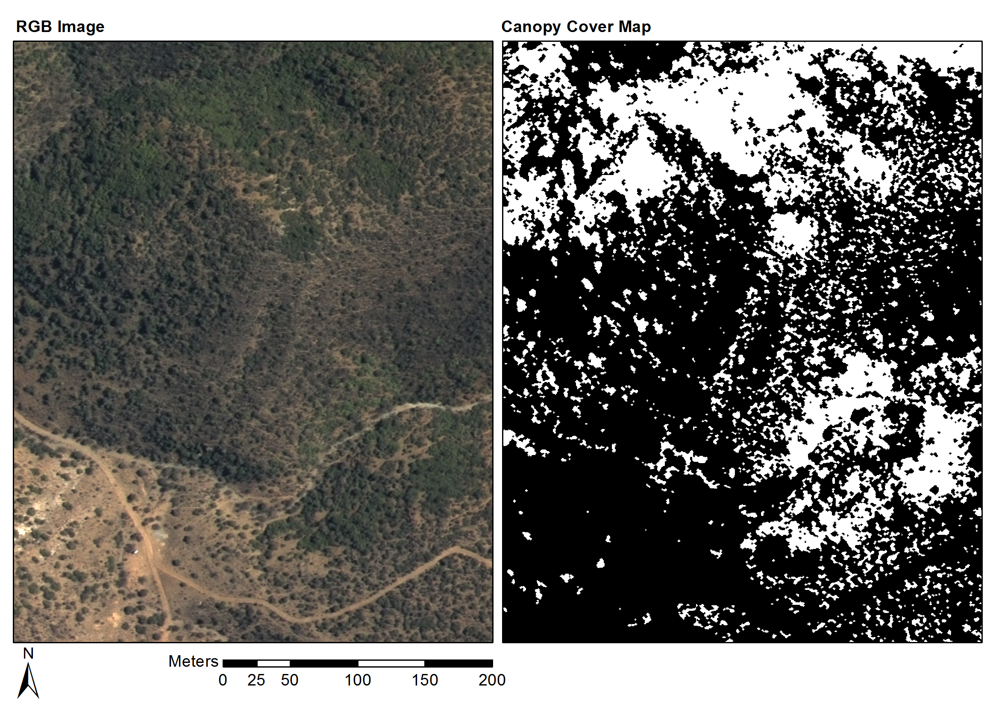

Figure 4.6 Groenfontein classification (Habitat: valley thicket with Spekboom)

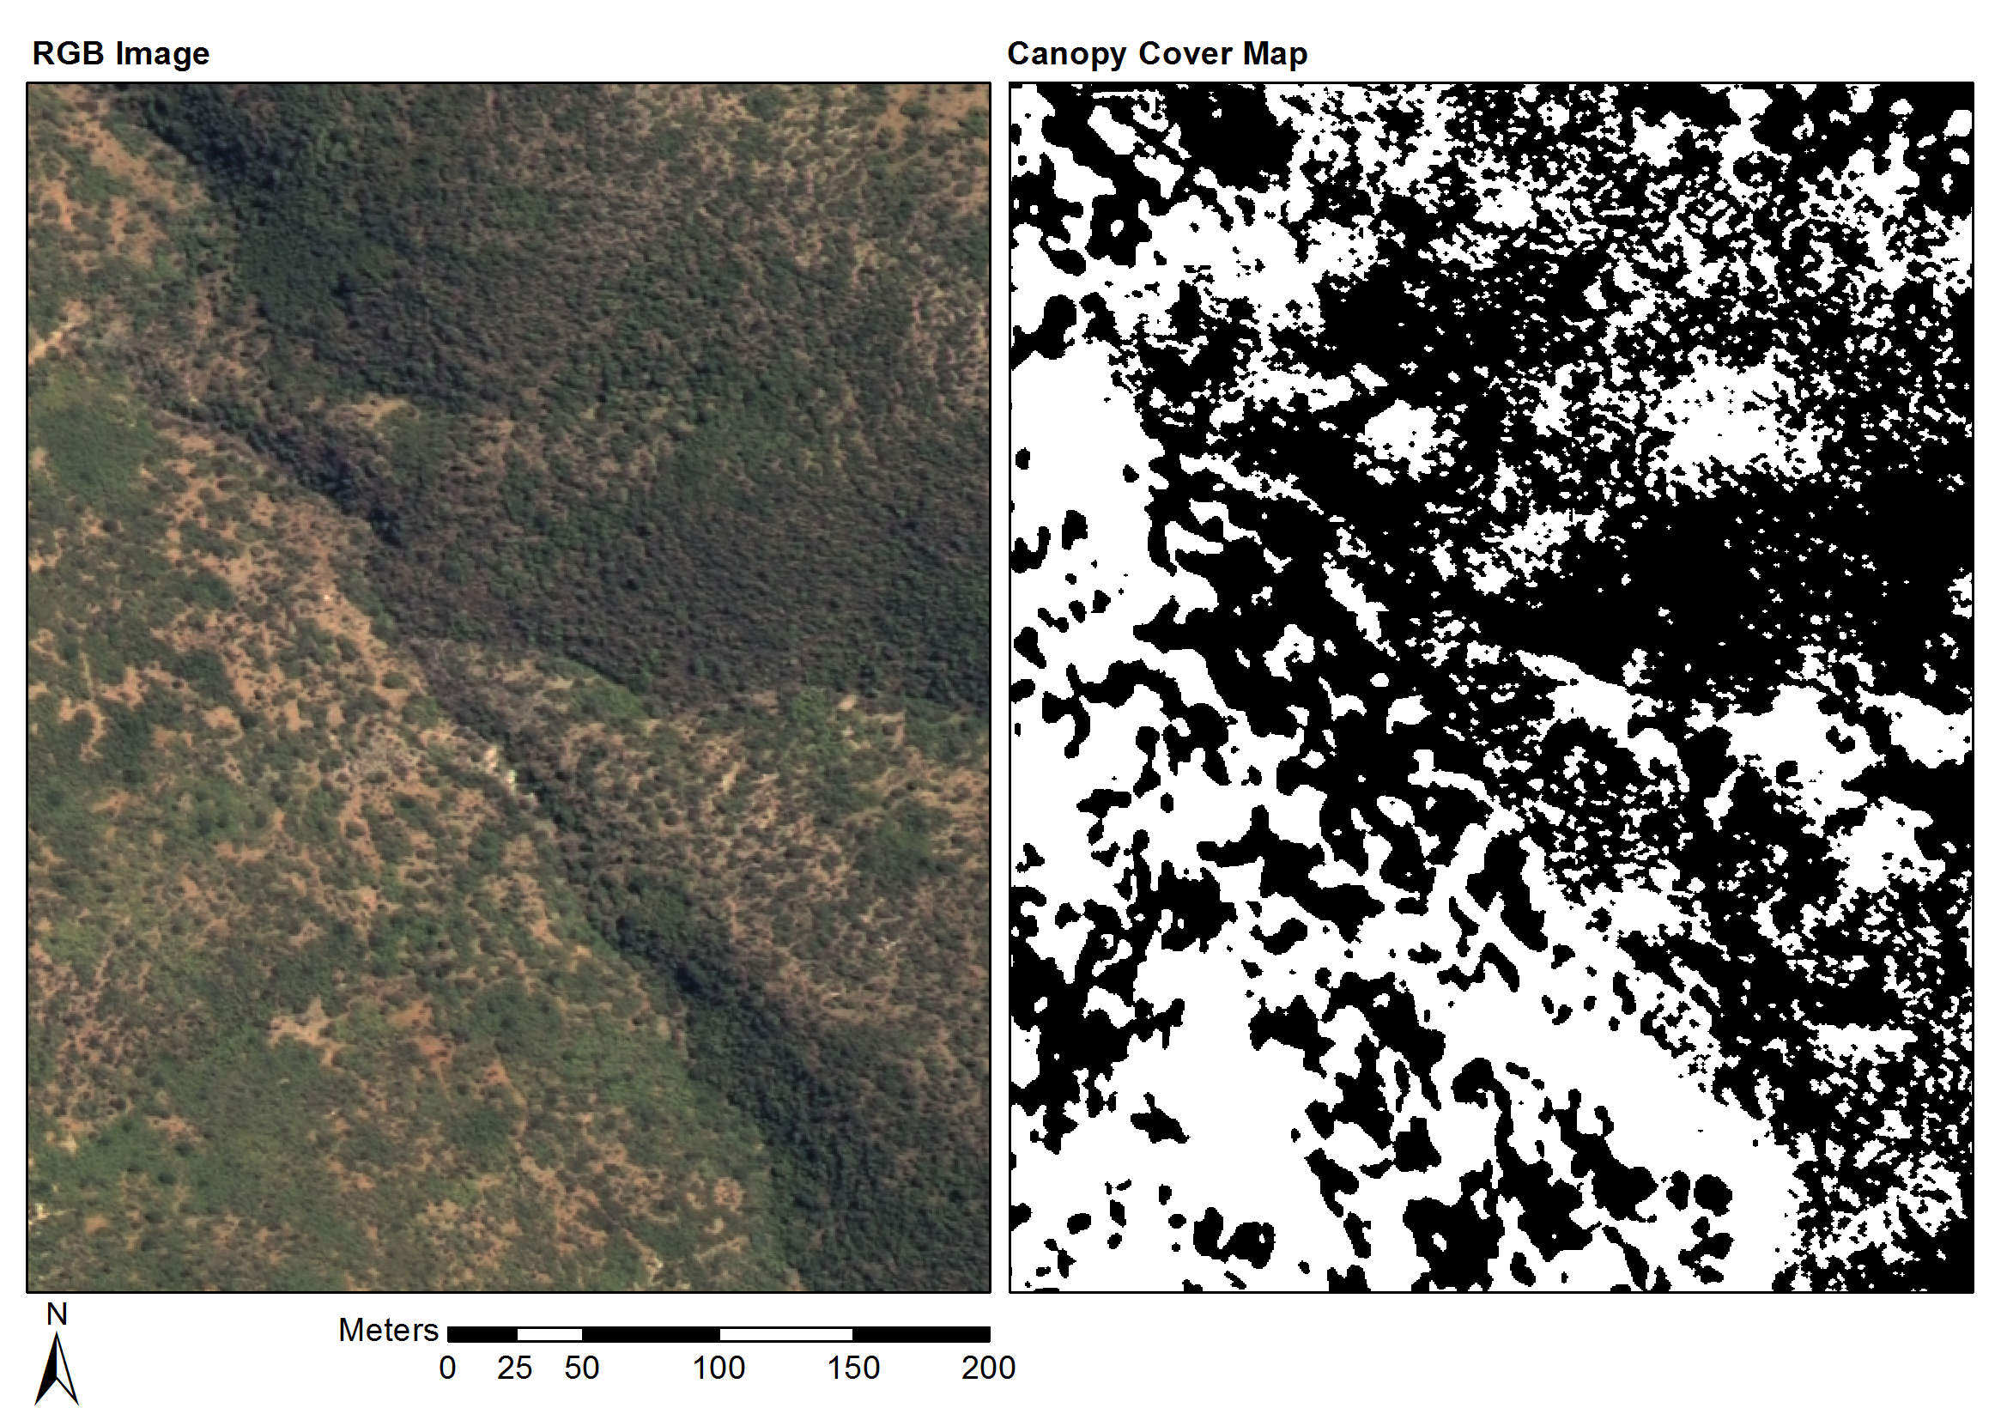

Figure 4.7 Matjiesvlei classification (Habitat: arid thicket with Spekboom)

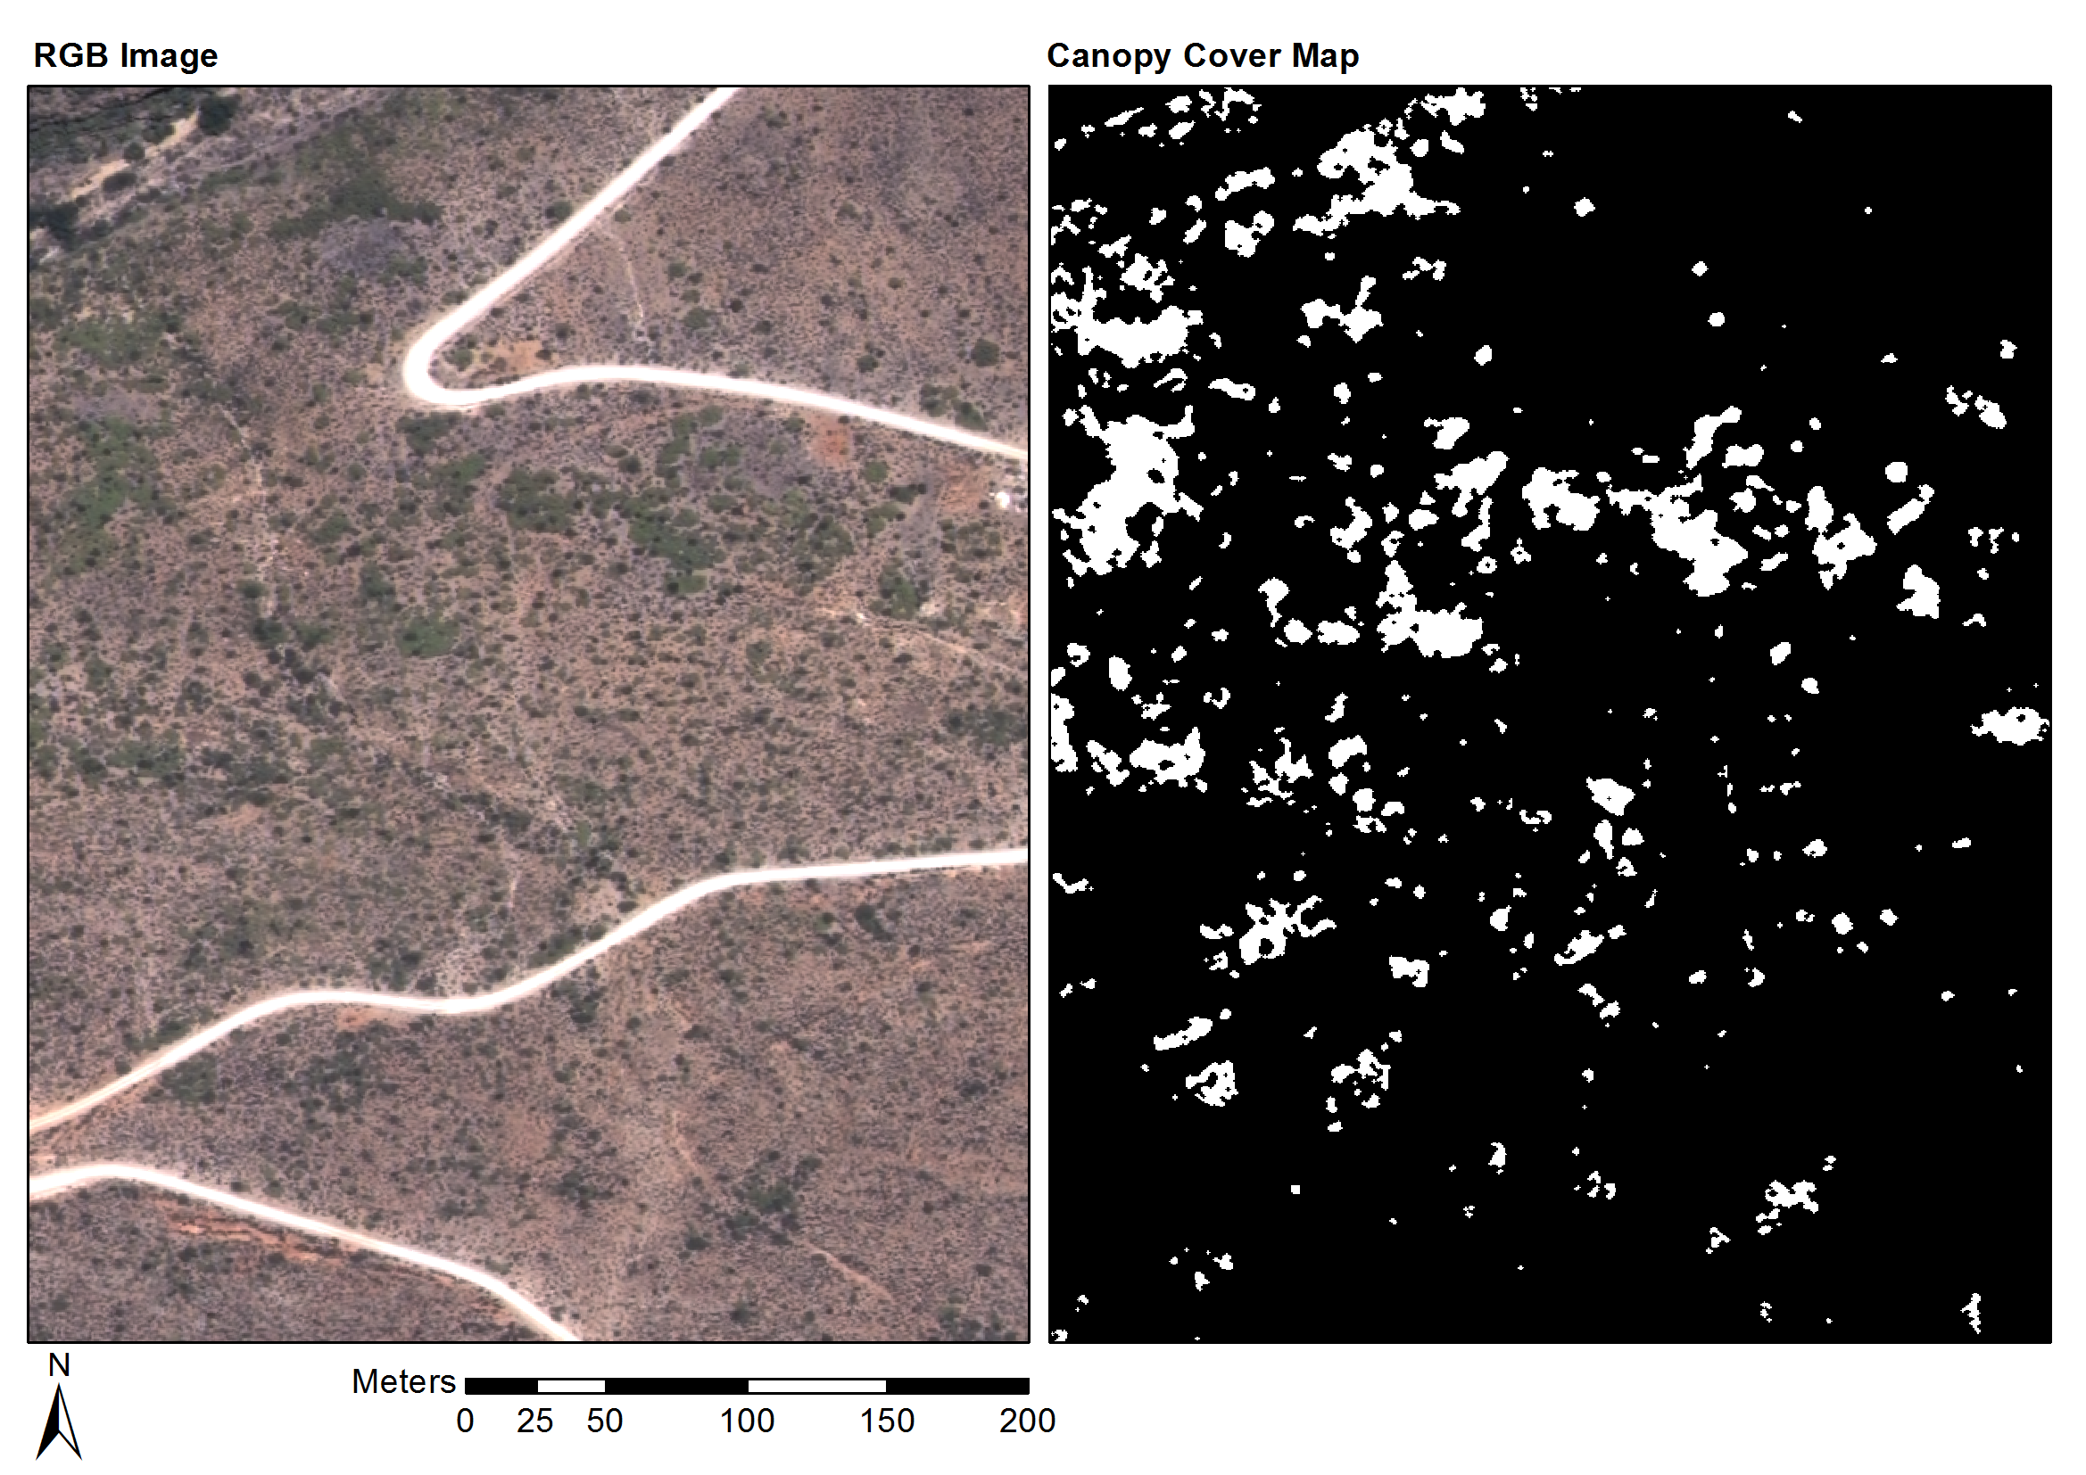

Figure 4.8 Rooiberg classification (Habitat: arid thicket with Spekboom and Fynbos mosaic)

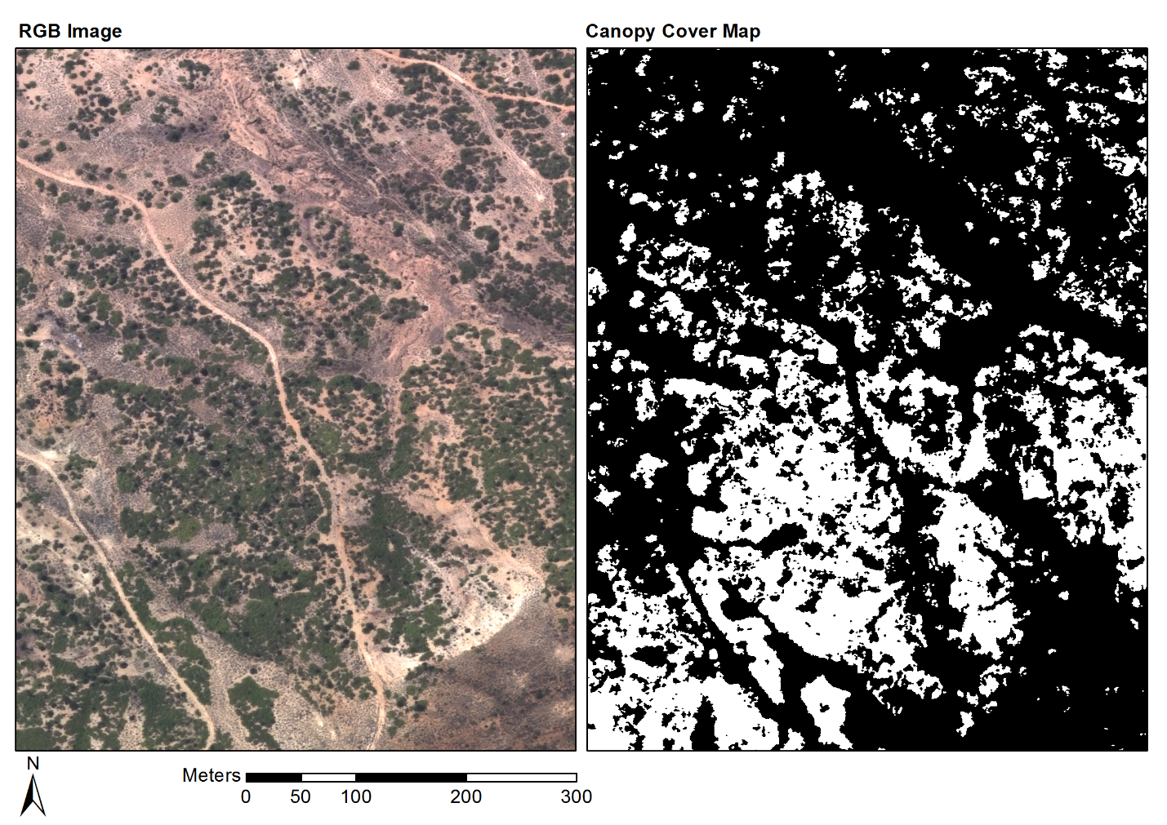

Figure 4.9 Grootkop classification (Habitat: arid thicket with Spekboom and Succulent Karoo mosaic)

## CONCLUSIONS

The per-pixel classification approach to *P. afra* canopy cover mapping was successful and good accuracies were achieved across the study area. Use of the mosaic cross calibration technique described in Chapter 2 was key in obtaining the radiometric consistency required to allow application of a single classification algorithm over an extended area. Six features, consisting of a combination of spectral, textural and vegetation index type measures, were selected with the feature clustering and ranking method described in Chapter 2. The feature set produced similarly good accuracies amongst a diverse set of candidate classifiers, confirming the feature selection method’s utility for finding informative features in the presence of correlation. A decision tree classifier was selected from the candidate classifiers due to its speed and accuracy on the field ground truth. Attention to the computational efficiency of feature extraction and classification methods assisted in being able to effectively experiment and process large volumes of images. The classifier produced a mean absolute canopy cover error of 5.86% and standard deviation of 4.85% over the 20 field ground truth sites.

While some variation in the classification accuracy was observed with habitat, the classifier was remarkably robust to the many sources of variation that make this a challenging problem. To the best of our knowledge, this is the first use of a mosaic of NGI aerial imagery in a quantitative remote sensing study. It is also one of very few examples of vegetation mapping using VHR imagery over a large area (Eisfelder, Kuenzer & Dech 2012; Lu 2006). The availability of a vegetation map covering the study area (Vlok, Cowling & Wolf 2005) and the assistance of an expert botanist in selecting and ground truthing the field sites were important contributors to the success of this study.

The map as it stands will provide a useful aid in selecting restoration sites and in choosing appropriate planting densities in the study area. By incorporating ground truth from new areas, the techniques used to produce this map can be extended to the rest of the thicket biome in the Little Karoo and Eastern Cape, where restoration work is also under way (Mills et al. 2010). Use of classifier developed here in combination with the Chapter 2 technique for calibration to a physical property of the surface, i.e. surface reflectance, enables repeated canopy cover monitoring of restoration sites over time. The availability of a *P. afra* canopy cover map will also be a valuable starting point for developing measures of other environmental variables such as biomass and biodiversity (Eisfelder, Kuenzer & Dech 2012; Suganuma et al. 2006; Ludwig, Reynolds & Whitson 1975).

While the mapping accuracies achieved compare well with related studies (Ghosh & Joshi 2014; Heumann 2011; Baraldi et al. 2010; Johansen et al. 2007; Mehner et al. 2004), there are many opportunities for improvement. Ancillary information such as slope aspect or habitat could be incorporated into the classifier, similarly to Thompson et al. (2009). This could be done by including it either as a feature or by designing separate classifiers for different ranges or categories of the ancillary variable. While spatial context was included in our classifier through the sliding window features and morphological post processing, texture information could be better exploited by following an object based approach (Blaschke 2010). Homogenous objects would allow the use of more descriptive texture features such as LBP’s and statistics of the GLCM. It was found that classifier performances on the image and field ground truth were not well correlated. This implied the image ground truth was not adequately representative of actual field variation. To obtain accurate pixel level ground truth it would be necessary to undertake a more precise field ground truthing exercise as it is not possible to label vegetation from visual inspection of the images with absolute certainty. Individual trees and *P. afra* clumps would have to be delineated across a range of habitats. Possible spatial inaccuracies between DGPS recorded polygons and the NGI orthrectified imagery could be adjusted by hand using the image as a visual reference.

REFERENCES

Adie H & Yeaton RI 2013. Regeneration dynamics in arid subtropical thicket, South Africa. *South African Journal of Botany* 88: 80–85.

Airbus Defence and Space 2014. Resolution and Spectral Bands [online]. Available from: http://www.astrium-geo.com/en/194-resolution-and-spectral-bands [Accessed June 14 2014].

Amorós López J, Izquierdo Verdiguier E, Gómez Chova L, Muñoz Marí J, Rodríguez Barreiro JZ, Camps Valls G & Calpe Maravilla J 2011. Land cover classification of VHR airborne images for citrus grove identification. *ISPRS Journal of Photogrammetry and Remote Sensing* 66 (1): 115–123.

Baraldi A, Durieux L, Simonetti D, Conchedda G, Holecz F & Blonda P 2010. Automatic spectral-rule-based preliminary classification of radiometrically calibrated SPOT-4/-5/IRS, AVHRR/MSG, AATSR, IKONOS/QuickBird/OrbView/GeoEye, and DMC/SPOT-1/-2 imagery—Part I: System design and implementation. *IEEE Transactions on Geoscience and Remote Sensing* 48 (3): 1299–1325.

Berk A, Anderson GP, Bernstein LS, Acharya PK, Dothe H, Matthew MW, Adler-Golden SM, Chetwynd JH, Richtsmeier SC, Pukall B, Allred CL, Jeong LS & Hoke ML 1999. MODTRAN4 radiative transfer modeling for atmospheric correction. In *Proceedings of SPIE - The International Society for Optical Engineering*, 348–353. Denver, CO: Society of Photo-Optical Instrumentation Engineers.

Bishop CM 2003. *Neural networks for pattern recognition*. New York: Oxford University Press.

Blaschke T 2010. Object based image analysis for remote sensing. *ISPRS Journal of Photogrammetry and Remote Sensing* 65 (1): 2–16.

Blauensteiner P, Wildenauer H, Hanbury A & Kampel M 2006. On colour spaces for change detection and shadow suppression. In Chum O & Franc V (eds) *Computer Vision Winter Workshop 2006*, 1–6. Telc, Czech Republic: Czech Pattern Recognition Society.

Bradski G 2000. The OpenCV library. *Dr. Dobb’s Journal of Software Tools* 25 (120): 122– 125.

Breiman L 1996. Bagging predictors. *Machine Learning* 24 (2): 123–140.

Breiman L 2001. Random Forests. *Machine Learning* 45 (1): 5–32.

Breiman L, Friedman J, Olshen R & Stone C 1984. *Classification and regression trees*. Calif.: Wadsworth.

Burges CJC 1998. A tutorial on support vector machines for pattern recognition. *Data Mining and Knowledge Discovery* 2 (2): 121–167.

Carleer AP, Debeir O & Wolff E 2005. Assessment of very high spatial resolution satellite image segmentations. *Photogrammetric Engineering & Remote Sensing* 71 (11): 1285–1294.

Chandelier L & Martinoty G 2009. A radiometric aerial triangulation for the equalization of digital aerial images and orthoimages. *Photogrammetric Engineering & Remote Sensing* 75 (2): 193–200.

Chander G, Meyer DJ & Helder DL 2004. Cross calibration of the Landsat-7 ETM+ and EO-1 ALI sensor. *IEEE Transactions on Geoscience and Remote Sensing* 42 (12): 2821–2831.

Collings S, Caccetta P, Campbell N & Wu X 2011. Empirical models for radiometric calibration of digital aerial frame mosaics. *IEEE Transactions on Geoscience and Remote Sensing* 49 (7): 2573–2588.

Collings S, Caccetta P, Campbell N & Wu X 2010. Techniques for BRDF Correction of Hyperspectral Mosaics. *IEEE Transactions on Geoscience and Remote Sensing* 48 (10): 3733–3746.

Cover TM 1974. The best two independent measurements are not the two best. *IEEE Transactions on Systems, Man, and Cybernetics* SMC-4 (1): 116–117.

Curran P, Smedley D, Thompson P & Knight AT 2012. Mapping restoration opportunity for collaborating with land managers in a carbon credit-funded restoration program in the Makana municipality, Eastern Cape, South Africa. *Restoration Ecology* 20 (1): 56–64.

Downey M, Uebbing R, Gehrke S & Beisl U 2010. RADIOMETRIC PROCESSING OF ADS IMAGERY : USING ATMOSPHERIC AND BRDF CORRECTIONS IN PRODUCTION. In *ASPRS 2010 Annual Conference*. San Diego, CA, USA.

Duelling DR, Minnis P & Nguyen L 2004. Calibration comparisons between SEVIRI, MODIS and GOES data. In *Second MSG RAO Workshop*, 149–153. Salzburg: European Space Agency.

Duin RPW & Tax DMJ 2005. Statistical Pattern Recognition. In Chen C & Wang P (eds) *Handbook of Pattern Recognition and Computer Vision, 3rd ed.*, 1–21. Singapore: World Scientific.

Eisfelder C, Kuenzer C & Dech S 2012. Derivation of biomass information for semi-arid areas using remote-sensing data. *International Journal of Remote Sensing* 33 (9): 2937–2984.

Fabricius C, Burger M & Hockey PAR 2003. Comparing biodiversity between protected areas and adjacent rangeland in xeric succulent thicket, South Africa: arthropods and reptiles. *Journal of Applied Ecology* 40 (2): 392–403.

Food and Agriculture Organization (FAO) 1989. Arid zone forestry: a guide for field technicians. [online]. Available from: http://www.fao.org/docrep/T0122E/t0122e03.htm [Accessed May 22 2012].

Forsyth G, Vlok J & Reyers B 2008. *Retention and restoration of the biodiversity of the Little Karoo*. CSIR Report No CSIR/NRE/ECO/ER/2008/0118/C. CSIR.

Gao C, Jiang X, Li X & Li X 2013. The cross-calibration of CBERS-02B/CCD visible-near infrared channels with Terra/MODIS channels. *International Journal of Remote Sensing* 34 (9-10): 3688–3698.

Gates DM 1980. *Biophysical Ecology*. New York: Springer.

GDAL Development Team 2014. Geospatial Data Abstraction Library [online]. Open Source Geospatial Foundation. Available from: http://www.gdal.org/.

Gehrke S 2010. Radiometric processing of ADS imagery: mosaicking of large image blocks. In *Opportunities for Emerging Geospatial Technologies*, 184–195. American Society for Photogrammetry and Remote Sensing Annual Conference 2010 held 26-30 April 2010. San Diego, United States: American Society for Photogrammetry and Remote Sensing.

Ghosh A & Joshi PK 2014. A comparison of selected classification algorithms for mapping bamboo patches in lower Gangetic plains using very high resolution WorldView 2 imagery. *International Journal of Applied Earth Observation and Geoinformation* 26: 298–311.

Guralnick LJ & Ting IP 1986. Seasonal response to drought and rewatering in Portulacaria afra (L.) Jacq. *Oecologia* 70: 85–91.

Hand DJ & Yu K 2001. Idiot’s Bayes - not so stupid after all? *International Statisitical Review* 69 (3): 385–398.

Hein L, de Ridder N, Hiernaux P, Leemans R, de Wit A & Schaepman M 2011. Desertification in the Sahel: Towards better accounting for ecosystem dynamics in the interpretation of remote sensing images. *Journal of Arid Environments* 75 (11): 1164–1172.

Heumann BW 2011. Satellite remote sensing of mangrove forests: Recent advances and future opportunities. *Progress in Physical Geography* 35 (1): 87–108.

Honkavaara E, Arbiol R, Markelin L, Martinez L, Cramer M, Bovet S, Chandelier L, Ilves R, Klonus S, Marshal P, Schläpfer D, Tabor M, Thom C & Veje N 2009. Digital airborne photogrammetry—a new tool for quantitative remote sensing?—A state-of-the-art review on radiometric aspects of digital photogrammetric images. In *Remote Sensing*, 577–605.

Intergraph 2008. Digital mapping camera system [online]. Available from: http://www.geospace.co.za/pdf/DMC Brochure.pdf.

Jain AK, Duin RPW & Mao J 2000. Statistical pattern recognition: a review. *IEEE Transactions on Pattern Analysis and Machine Intelligence* 22 (1): 4–37.

Jiang G-M & Li Z-L 2009. Cross-calibration of MSG1-SEVIRI infrared channels with Terra-MODIS channels. *International Journal of Remote Sensing* 30 (3): 753–769.

Johansen K, Coops NC, Gergel SE & Stange Y 2007. Application of high spatial resolution satellite imagery for riparian and forest ecosystem classification. *Remote Sensing of Environment* 110 (1): 29–44.

Kamei A, Nakamura K, Yamamoto H, Nakamura R, Tsuchida S, Yamamoto N, Sekiguchi S, Kato S, Liu C, Hsu K & Wu A 2012. Cross calibration of Formosat-2 remote sensing instrument (RSI) using Terra Advanced Spaceborne Thermal Emission and Reflection Radiometer (ASTER). *IEEE Transactions on Geoscience and Remote Sensing* 50 (11): 4821–4831.

Kauth RJ & Thomas GS 1976. The tasselled cap -- a graphic description of the spectral-temporal development of agricultural crops as seen by LANDSAT. In *Symposium on Machine Processing of Remotely Sensed Data*, 4B41–4B51. Purdue University of West Lafayette, Indiana, USA: IEEE.

Knight AT, Cowling RM, Boshoff AF, Wilson SL & Pierce S 2011. Walking in STEP: Lessons for linking spatial prioritisations to implementation strategies. *Biological Conservation* 144 (1): 202–211.

Lechmere-Oertel RG, Kerley G, Mills AJ & Cowling RM 2008. Litter dynamics across browsing-induced fenceline contrasts in succulent thicket, South Africa. *South African Journal of Botany* 74 (4): 651–659.

Lelong CCD, Burger P, Jubelin G, Roux B, Labbé S & Baret F 2008. Assessment of unmanned aerial vehicles imagery for quantitative monitoring of wheat crop in small plots. *Sensors* 8 (5): 3557–3585.

Lévesque J & King DJ 2003. Spatial analysis of radiometric fractions from high-resolution multispectral imagery for modelling individual tree crown and forest canopy structure and health. *Remote Sensing of Environment* 84 (4): 589–602.

Li L, Yang J & Wang Y 2012. Cross-calibration of HJ-1B/CCD1 image based on Aqua/MODIS data. In *2012 Second International Workshop on Earth Observation and Remote Sensing Applications*, 116–119. Shanghai, China: IEEE.

Li Z, Hayward RF, Zhang J, Jin H & Walker RA 2010. Evaluation of spectral and texture features for object-based vegetation species classification using support vector machines. In Wagner W & Székely B (eds) *ISPRS TC VII Symposium – 100 Years ISPRS*, 122–127. Vienna, Austria: IAPRS.

Liu J-J, Li Z, Qiao Y-L, Liu Y-J & Zhang Y-X 2004. A new method for cross-calibration of two satellite sensors. *International Journal of Remote Sensing* 25 (23): 5267–5281.

López DH, García BF, Piqueras JG & Guillermo VA 2011. An approach to the radiometric aerotriangulation of photogrammetric images. *ISPRS Journal of Photogrammetry and Remote Sensing* 66 (6): 883–893.

Lu D 2006. The potential and challenge of remote sensing based biomass estimation. *International Journal of Remote Sensing* 27 (7): 1297–1328.

Ludwig JA, Reynolds JF & Whitson PD 1975. Size-biomass relationships of several Chihuahuan desert shrubs. *American Midland Naturalist* 94 (2): 451–461.

Van Luijk G, Cowling RM, Riksen MJPM & Glenday J 2013. Hydrological implications of desertification: Degradation of South African semi-arid subtropical thicket. *Journal of Arid Environments* 91: 14–21.

Manabe S & Strickler RF 1964. Thermal equilibrium of the atmosphere with a convective adjustment. *Journal of the Atmospheric Sciences* 21 (4): 361–385.

Marais C, Cowling RM & Powell M 2009. Establishing the platform for a carbon sequestration market in South Africa: The Working for Woodlands Subtropical Thicket Restoration Programme. In *XIII World Forestry Congress*, 1–13. Buenos Aires, Argentina.

Markelin L, Honkavaara E, Schläpfer D, Bovet S & Korpela I 2012. Assessment of radiometric correction methods for ADS40 imagery. *Photogrammetrie - Fernerkundung - Geoinformation* 2012 (3): 251–266.

Mehner H, Cutler M, Fairbairn D & Thompson G 2004. Remote sensing of upland vegetation: the potential of high spatial resolution satellite sensors. *Global Ecology and Biogeography* 13 (4): 359–369.

Mills AJ, Blignaut J, Cowling RM, Knipe A, Marais C, Marais S, Pierce S, Powell M, Sigwela A & Skowno A 2010. *Investing in sustainability. Restoring degraded thicket, creating jobs, capturing carbon and earning green credit.* Climate Action Partnership, Cape Town and Wilderness Foundation, Port Elizabeth.

Mills AJ & Cowling RM 2010. Below-ground carbon stocks in intact and transformed subtropical thicket landscapes in semi-arid South Africa. *Journal of Arid Environments* 74 (1): 93–100.

Mills AJ & Cowling RM 2006. Rate of carbon sequestration at two thicket restoration sites in the Eastern Cape, South Africa. *Restoration Ecology* 14 (1): 38–49.

Mills AJ, Cowling RM, Fey M, Kerley G, Donaldson J, Sigwela A, Skowno A & Rundel P 2005. Effects of goat pastoralism on ecosystem carbon storage in semiarid thicket, Eastern Cape, South Africa. *Austral Ecology* 30: 797–804.

Mills AJ & Fey M 2004. Transformation of thicket to savanna reduces soil quality in the Eastern Cape, South Africa. *Plant and Soil* 265 (1-2): 153–163.

Mills AJ, Turpie JK, Cowling RM, Marais C, Kerley G, Richard G, Sigwela A & Powell M 2007. Assessing costs, benefits, and feasibility of restoring natural capital in Subtropical Thicket in South Africa. In Aronson J, Milton S & Blignaut J (eds) *Restoring Natural Capital: Science, Business and Practice (The Science and Practice of Ecological Restoration Series)*, 179–187. Washington DC: Island Press.

Mingguo Z, Qianguo C & Mingzhou Q 2009. The Effect of Prior Probabilities in the Maximum Likelihood Classification on Individual Classes. *Photogrammetric Engineering & Remote Sensing* 75 (9): 1109–1117.

MODIS Land Team 2014. EOS validation status for MODIS BRDF/albedo: MCD43 [online]. Available from: http://landval.gsfc.nasa.gov/ProductStatus.php?ProductID=MOD43 [Accessed June 6 2014].

Mouton J 2001. *How to succeed in your master’s and doctoral studies : a South African guide and resource book*. Pretoria: Van Schaik Publishers.

Myneni RB, Hall FG, Sellers PJ & Marshak AL 1995. The interpretation of spectral vegetation indexes. *IEEE Transactions on Geoscience and Remote Sensing* 33 (2): 481–486.

NASA 2014. Components of MODIS [online]. Available from: http://modis.gsfc.nasa.gov/about/specifications.php [Accessed June 14 2014].

National Geo-spatial Information 2012. National aerial photography and imagery programme [online]. Department of Rural Development and Land Reform (DRDLR). Available from: http://www.ngi.gov.za/index.php/Image-tabs-home/national-aerial-photography-and-imagery-programme.html [Accessed May 22 2012].

OpenCV Development Team 2014. OpenCV documentation [online]. Open Source Computer Vision Library. Available from: http://docs.opencv.org/.

Pierce S, Cowling RM, Knight AT, Lombard AT, Rouget M & Wolf T 2005. Systematic conservation planning products for land-use planning: Interpretation for implementation. *Biological Conservation* 125 (4): 441–458.

Pohl C & Van Genderen JL 1998. Review article Multisensor image fusion in remote sensing: Concepts, methods and applications. *International Journal of Remote Sensing* 19 (5): 823–854.

Puissant A, Hirsch J & Weber C 2005. The utility of texture analysis to improve per-pixel classification for high to very high spatial resolution imagery. *International Journal of Remote Sensing* 26 (April 2015): 733–745.

Restoration Research Group 2012. Intact and degraded Spekboomveld [online]. Available from: http://www.r3g.co.za/spekboom.htm.

Richter R & Schlapfer D 2012. Atmospheric / Topographic Correction for Airborne Imagery ( ATCOR-4 User Guide , Version 6 . 2 BETA , February 2012 ). (February).

Richter R & Schläpfer D 2002. Geo-atmospheric processing of airborne imaging spectrometry data. Part 2: Atmospheric/topographic correction. *International Journal of Remote Sensing* 23 (April 2015): 2631–2649.

Roujean J-L, Leroy M & Deschamps P-Y 1992. A bidirectional reflectance model of the Earth’s surface for the correction of remote sensing data. *Journal of Geophysical Research* 97 (D18): 20455.

Sahu B & Mishra D 2011. A novel approach for selecting informative genes from gene expression data using signal-to-noise ratio and t-statistics. In *2011 2nd International Conference on Computer and Communication Technology (ICCCT-2011)*, 5–10. Allahabad, India: IEEE.

Schaepman-Strub G, Schaepman ME, Painter TH, Dangel S & Martonchik JV 2006. Reflectance quantities in optical remote sensing—definitions and case studies. *Remote Sensing of Environment* 103 (1): 27–42.

Serra J & Soille P (eds). 1994. Mathematical morphology and its applications to image processing. In *2nd International Symposium on Mathematical Morphology (ISMM’94)*, 383. Computational imaging and vision. Kluwer Academic Publishers.

Sigwela A, Kerley G, Mills AJ & Cowling RM 2009. The impact of browsing-induced degradation on the reproduction of subtropical thicket canopy shrubs and trees. *South African Journal of Botany* 75 (2): 262–267.

Singh M, Malhi Y & Bhagwat S 2014. Biomass estimation of mixed forest landscape using a Fourier transform texture-based approach on very-high-resolution optical satellite imagery. *International Journal of Remote Sensing* 35 (9): 3331–3349.

Song C 2004. Cross-sensor calibration between Ikonos and Landsat ETM+ for spectral mixture analysis. *IEEE Geoscience and Remote Sensing Letters* 1 (4): 272–276.

Statistics South Africa 2011. *Quarterly labour force survey quarter 1, 2011*. P0211. Pretoria: Statistics South Africa.

Strahler AH, Wanner W, Lucht W, Schaaf CB, Tsang T, Gao F, Li X, Muller J-P, Lewis P & Barnsley MJ 1999. MODIS BRDF/albedo product: algorithm theoretical basis document version 5.0 [online]. Available from: http://modis.gsfc.nasa.gov/data/atbd/atbd_mod09.pdf [Accessed May 27 2014].

Strobl C, Boulesteix A-L, Kneib T, Augustin T & Zeileis A 2008. Conditional variable importance for random forests. *BMC bioinformatics* 9: 307.

Stuart-Hill G 1992. Effects of elephants and goats on the Kaffrarian succulent thicket of the eastern Cape, South Africa. *Journal of Applied Ecology* 29 (3): 699–710.

Suganuma H, Abe Y, Taniguchi M, Tanouchi H, Utsugi H, Kojima T & Yamada K 2006. Stand biomass estimation method by canopy coverage for application to remote sensing in an arid area of Western Australia. *Forest Ecology and Management* 222 (1-3): 75–87.

Szekely GJ & Rizzo ML 2005. Hierarchical clustering via joint between-within distances: extending Ward’s minimum variance method. *Journal of Classification* 22 (2): 151–183.

Teillet P., Barker J., Markham B., Irish R., Fedosejevs G & Storey J. 2001. Radiometric cross-calibration of the Landsat-7 ETM+ and Landsat-5 TM sensors based on tandem data sets. *Remote Sensing of Environment* 78 (1-2): 39–54.

Thompson M, Vlok J, Rouget M, Hoffman MT & Cowling RM 2009. Mapping grazing-induced degradation in a semi-arid environment: A rapid and cost effective approach for assessment and monitoring. *Environmental Management* 43: 585–596.

Thompson MW, Vlok J, Cowling RM, Cundill SL & Mudau N 2005. *A land transformation map of the Little Karoo*. Pretoria: GeoterraImage.

Tolosi L & Lengauer T 2011. Classification with correlated features: unreliability of feature ranking and solutions. *Bioinformatics* 27 (14): 1986–1994.

Trias-Sanz R, Stamon G & Louchet J 2008. Using colour, texture, and hierarchial segmentation for high-resolution remote sensing. *ISPRS Journal of Photogrammetry and Remote Sensing* 63 (2): 156–168.

Turner MD 2003. Methodological reflections on the use of remote sensing and geographic information science in human ecological research. *Human Ecology* 31 (2): 255–279.

Vermote EF, Tanre D, Deuze JL, Herman M & Morcette J-J 1997. Second simulation of the satellite signal in the solar spectrum, 6S: an overview. *IEEE Transactions on Geoscience and Remote Sensing* 35 (3): 675–686.

Vicente-Serrano S, Pérez-Cabello F & Lasanta T 2008. Assessment of radiometric correction techniques in analyzing vegetation variability and change using time series of Landsat images. *Remote Sensing of Environment* 112 (10): 3916–3934.

Vlok J, Cowling RM & Wolf T 2005. A vegetation map for the Little Karoo. Unpublished maps and report for a SKEP project supported by CEPF grant no 1064410304.

Vyver ML, Cowling RM, Campbell EE & Difford M 2012. Active restoration of woody canopy dominants in degraded South African semi-arid thicket is neither ecologically nor economically feasible. *Applied Vegetation Science* 15 (1): 26–34.

Van der Vyver ML, Cowling RM, Mills AJ & Difford M 2013. Spontaneous return of biodiversity in restored subtropical thicket: Portulacaria afra as an ecosystem engineer. *Restoration Ecology* 21 (6): 736–744.

Wulder MA, Hall RJ, Coops NC, Steven E & Franklin SE 2004. High spatial resolution remotely sensed data for ecosystem characterization. *BioScience* 54 (6): 511–521.

Xu M, Watanachaturaporn P, Varshney P & Arora M 2005. Decision tree regression for soft classification of remote sensing data. *Remote Sensing of Environment* 97 (3): 322–336.

Yousef M, Jung S, Showe LC & Showe MK 2007. Recursive cluster elimination (RCE) for classification and feature selection from gene expression data. *BMC Bioinformatics* 8 (144).

Yu L & Liu H 2004. Efficient feature selection via analysis of relevance and redundancy. *Journal of Machine Learning Research* 5 (2004): 1205–1224.

Yu Q, Gong P, Clinton N, Biging G, Kelly M & Schirokauer D 2006. Object-based detailed vegetation classification with airborne high spatial resolution remote sensing imagery. *Photogrammetric Engineering & Remote Sensing* 72 (7): 799–811.

**PERSONAL COMMUNICATIONS**

List your personal communications here.

See the departmental guidelines for instructions.

**APPENDICES**

|  |  |  |
| --- | --- | --- |
| Appendix A | Title of first appendix | 8 |
| Appendix B | Title of second appendix | 9 |

**APPENDIX A**

Title of fist appendix

Appendix content

**APPENDIX B**

Title of second appendix

Content

Note: These references were automatically inserted here (at the end of the document) by EndNote and must be manually copied to the reference list. Alternatively, one can put the appendixes in a separate document so that the reference list is at the very end of the document. This will automatically update your reference list as you work on the document.

Saaty TL & Vargas LG 1991. *Prediction, projection and forcasting.* Boston: Kluwer Academic Publishers.

Turner D 2005. Transkei and ciskei land type survey [online]. ARC. Available from <http://www.arc-iscw.agric.za/main/projects/landtype.htm> [Accessed 23-06-2005].